<CUBE> USER GUIDE (ugu)



Document ID | DigDev_Cube_User_Guide_v1.3
Product | Cube
Environment | All
Confidentiality Level | Internal / Restricted

CONTENTS
1 DOCUMENT INFORMATION 8
1.1 Validation 8
1.2 Document Distribution 8
1.3 Version Control 8
2 PREFACE 9
2.1 About this document 9
2.2 Related documents 9
2.3 Who should read this document 9
2.4 Terminology 9
2.5 Conventions Used 11
3 CUBE OVERVIEW 12
3.1 Description 12
3.2 User Interface 12
3.2.1 Login Page 13
4 CUSTOMERZ SECTION 14
4.1 Customers 14
4.2 Customer Contacts 14
4.3 Sites 15
4.4 Reviews 15
4.5 CC Transactions 15
4.6 Credit Limit Requests 15
4.7 Accounting Inquiries 15
4.8 Billing Preferences 15
5 SALEZ SECTION 16
5.1 Products 16
5.1.1 Toilets 16
5.1.2 Roll-offs 16
5.1.3 Containers 16
5.1.4 Fencing 16
5.1.5 Front Loads 16
5.1.6 Equipment Rentals 16
5.1.7 Perm Roll-off 16
5.1.8 Grease Trap 17
5.1.9 Other Services 17
5.2 Service Tickets 17
5.3 Line Items 17
5.4 Invoices 17
5.5 AP Hub 17
5.6 Pricing History 17
5.7 Z Sight Monitors 17
5.8 Assets 18
6 OPERATIONZ SECTION 19
6.1 Service Providers 19
6.1.1 Page Header 19
6.1.2 Service provider summary 20
6.1.3 Service provider view 21
6.2 Service Provider Contacts 23
6.2.1 Creating a Service Provider Contact 24
6.2.2 Contact Record Actions 25
6.2.3 Additional Table Controls 26
6.3 Service Provider Notes 26
6.3.1 Creating a Service Provider Note 26
6.3.2 Note Types 27
6.4 Fulfillment Tickets 28
6.5 SPM Tickets 28
6.6 Pricing Zones 28
6.7 Pricings 28
6.8 Service Provider Quotes 28
6.9 SPM Activities 28
6.10 Price Increases 28
6.11 Out of Stock 28
6.12 Zip Codes 29
6.13 Service Provider Ratings 29
6.14 Service Provider Business Hours 29
7 ZEEPZ SECTION 30
7.1 Leads 30
7.2 Employees 30
7.3 Bonus Points 30
7.4 Badges 30
8 ADMINISTRATORZ SECTION 31
8.1 Products 31
8.2 Product Codes 31
8.3 Ticket Codes 31
8.4 States 31
8.5 Notes 31
8.6 Service Provider Link 31
8.7 Tasks 32
8.8 Lead Sources 32
8.9 Lead Parent 32
8.10 Answered Phone Calls 32
9 USERZ SECTION 33
9.1 Users 33
9.2 Roles 33
9.3 Permissions 33
9.4 Groups 34
10 DASHBOARDZ SECTION 35
10.1 Role Select 35
10.2 CSS Dashboard 36
10.2.1 CSS Dashboard Summary 36
10.2.2 Revenue & Performance 36
10.2.3 Close Ratio 37
10.2.4 Tasks & Activities 37
10.2.5 Account Health 38
10.2.6 Billing Queue 38
10.2.7 Accounting Inquiries 39
10.2.8 Aging & Financial Health 39
10.3 AM Dashboard 40
10.3.1 Dashboard Summary 40
10.3.2 Revenue & Performance 40
10.3.3 Customer Health 40
10.3.4 Fulfillment Snapshot 42
10.3.5 Revenue Leaderboard 44
10.3.6 My Workflow 45
10.3.7 Accounting Inquiries 45
10.3.8 Money at Risk 46
10.3.9 Open Tasks 49
10.4 BDR Dashboard 50
10.4.1 Timeframe Filter 50
10.4.2 KPI Summary 50
10.4.3 Sales Performance 51
10.4.4 Close Ratio Performance 51
10.4.5 Call Activity 52
10.4.6 Call Evaluation 53
10.5 BDR Supervisor Dashboard 53
10.5.1 KPI Summary 53
10.5.2 Team Performance Overview 55
10.5.3 Call Activity 55
10.5.4 Sales Performance 56
10.5.5 Revenue Performance 56
10.5.6 Payout Tracking 57
10.6 CSM Dashboard 58
10.6.1 KPI Summary 58
10.6.2 Customer Activity 58
10.7 PSP Specialist 59
10.7.1 PSP Performance 59
10.7.2 PSP Status Overview 60
10.7.3 Accounting Inquiries 60
10.7.4 Inquiry Status Breakdown 61
10.7.5 PSP Revenue 61
10.7.6 My Providers 62
10.7.7 Documentation Alerts 63
10.7.8 SPM Tickets 63
10.8 Service Provider Summary 64
10.8.1 Service Provider Snapshot 64
10.8.2 Provider Lifecycle Distribution 64
10.8.3 PSP by Specialist 64
10.8.4 PSP Performance by Product 65
10.8.5 Compliance Risk 65
10.8.6 Accounting Inquiries 65
10.8.7 Revenue by Provider Type 66
10.9 SPM Specialist Dashboard 66
10.9.1 Ticket Summary 66
10.9.2 Ticket Aging Buckets 66
10.9.3 Average Resolution Time 67
10.9.4 Compliance Risk 67
10.9.5 COI Expiration Timeline 68
10.9.6 COI Upload Activity 68
10.9.7 Provider Lifecycle Distribution 68
10.9.8 Operational Readiness 69
10.10 Service Provider Team Lead Dashboard 69
10.10.1 Team Members 69
10.10.2 PSP Specialists Overview 70
10.10.3 Approved PSPs and Monthly Approvals 70
10.10.4 PSP Sales Win Rate Summary 71
10.10.5 Open Accounting Inquiries by PSP Specialist 71
10.10.6 Compliance / Documentation 71
10.10.7 Event Toilet Confirmation 72
10.11 Tonnage 72
10.11.1 Event Toilet Confirmation 72
10.11.2 Confirmation Progress 73
10.11.3 Status Breakdown 73
10.11.4 Tonnage Overview 73
10.11.5 Completion Rate 74
10.11.6 Missing Tonnage - Aging Buckets 74
10.11.7 Top Providers Missing Tonnage 75
10.11.8 Tonnage Inputted By 75
11 REPORTZ SECTION 76
11.1 Documentation Compliance 76
11.2 PSP Coverage Map 77
11.3 Static Reports 78
11.4 Custom Reports 79
11.5 AI Reports 80
11.6 Power BI Reports 80
12 OVERALL SYSTEM FUNCTIONALITIES 81
12.1 Bulk Actions 81
12.2 Export and Print Options 81
12.3 Filtering and Ordering 82
12.4 Search Bar 82
12.5 Table Views 82
12.6 Reports 83
13 SETTINGS 85
13.1 Header Controls 85
13.1.1 Profile 85
13.1.2 Inbox 85
13.1.3 Settings 85
14 USER ROLES 86
15 WORKING PROCEDURES 89
15.1 Account Manager Working Procedures 89
15.1.1 Create and Manage a Customer Record 89
15.1.2 Manage Service Sites 90
15.2 Customer Success Specialist Working Procedures 92
15.3 Admin Working Procedures 92
16 APPROVAL SIGNATURES 93

DOCUMENT INFORMATION

Validation
Name |  | Role | Date (dd/mm/aa)
Issued by | Oscar Rondon | Technical Writer | 26/10/2026
Verified by | Justin Tuttle | Systems Operations Manager | 26/10/2026
Approved by | Anthony Bures | Digital Development Manager | 26/10/2026

Document Distribution
Normal | Role
Oscar Rondon | Technical Writer
Anthony Bures | Digital Development Manager
Justin Tuttle | Systems Operations Manager

Version Control
Version | Date | Author | Description of changes
1.0 | 26/03/2026 | Oscar Rondon | 1st version of the CUBE User Guide document (Including the feedback from the pre-demo meetings).
1.1 | 25/06/2026 | Oscar Rondon | 2nd version of the CUBE User Guide document (Including dashboard and service provider updates).
1.2 | 20/10/2026 | Oscar Rondon | 3rd version of the CUBE User Guide document (Reorganizing the guide and include dashboard, reports and service provider updates).
1.3 | 26/10/2026 | Oscar Rondon | 4th version of the CUBE User Guide document (Includes service provider contacts and service provider notes features).
1.4 | 26/10/2026 | Oscar Rondon | 5th version of the CUBE User Guide document (Includes service provider module, overview and “new service provider” feature).

PREFACE

About this document
This document provides the User Guide (UGU) for the CUBE platform, describing the main features, user interface components, roles, and operational workflows available within the system.
The purpose of this guide is to help users understand how to navigate the application and perform common operational tasks within CUBE. It includes descriptions of the user interface, explanations of system modules, and step-by-step working procedures for typical activities performed in the platform.
This document is intended to support onboarding, training, and daily operational use of the CUBE system.

Related documents
All documents or elements used for reference are presented in the following table:
Title | Reference | Author | Version
SOP | HUB SOP | Oscar Rondon | 1.0

Who should read this document
This document is intended for users who interact with the CUBE platform as part of their operational responsibilities. These users may include:
- Account Managers, responsible for managing customer records, service sites, and supporting service-related workflows.
- Customer Success Specialists, responsible for managing leads and supporting internal engagement features such as bonus points and badges.
- Cube Administrators, responsible for managing user access, roles, permissions, and system configuration.
- ZTERS team members, who require an understanding of the CUBE platform for operational, coordination, or support purposes.
This guide is also useful for new team members, support personnel, and stakeholders who need a clear understanding of the platform’s functionality, structure, and core workflows.

Terminology
The following terminology is organized by category to separate system concepts, business records, and operational roles or functional groups used in CUBE.
System and Application Terms
Term Used | Description
CUBE | The internal web application used to manage customers, service locations, operational resources, and reporting tools within the ZTERS platform.
Dashboardz | A CUBE section that provides role-based dashboards with key indicators, workload items, alerts, performance metrics, and operational summaries.
Module | A functional area within CUBE used to manage a specific type of information or process.
User Role | A predefined set of permissions that determines what actions a user can perform within the system.
Bulk Actions | System functionality that allows users to perform actions on multiple records simultaneously within data tables.
Data Export | A functionality that allows users to extract system data, such as CSV files, for external use, reporting, or analysis.
Report | A system-generated view or dataset used to analyze operational or business information within the platform.

Business Records and Data Objects
Term Used | Description
Customer | An individual or organization receiving services managed through the CUBE system.
Site | A physical location associated with a customer where services are delivered or maintained.
Service Provider | A Service Provider or partner responsible for delivering services associated with customer sites.
Service Ticket | A record representing a customer request or operational task, used to track the lifecycle of a service from creation to completion.
Fulfillment Ticket | A record used to manage and track the execution and delivery of services by service providers.
Line Item | A detailed component within a service ticket that defines specific services, quantities, and pricing.
Invoice | A financial document generated for a customer that summarizes charges for services provided.
Service Provider Quote | A price estimate provided by a service provider for fulfilling a specific service request.
Pricing Zone | A defined geographic or operational area used to determine service pricing.
Asset | A resource or item tracked within the system, associated with customers, services, or operations.
Bonus Points | An internal recognition system used to reward team members for achievements or contributions.
Badge | A recognition element assigned to users based on achievements or participation within the platform.

Operational Roles and Functional Groups
Term Used | Description
AM | Account Manager. A role responsible for managing customer records, service sites, and related customer-facing workflows.
CSS | Customer Success Specialist. A role responsible for supporting customer success activities and related operational workflows.
CWS | Commercial Waste Services. A functional group within ZTERS responsible for managing waste service operations, including monitoring tools and asset-related functionalities.
SPM | Service Provider Management. A functional group responsible for managing Service Provider-related configurations, such as service provider data, pricing, and Service Provider coordination.
Leads | A functional group or role focused on managing sales leads and pipeline activities within the platform.
PSP Specialist | A role focused on managing assigned PSP-related provider activity, documentation, performance, and follow-up items.
SPM Specialist | A role focused on monitoring service provider management activities, including tickets, compliance risk, COI activity, and operational readiness.
Service Provider Team Lead | A supervisory role focused on reviewing team workload, provider assignments, approvals, documentation follow-up, and service provider performance.
Tonnage | An operational function or user group focused on tracking event toilet confirmations, final tonnage, missing tonnage, and related follow-up activity.
Cube Admin | A role responsible for managing system configuration, user access, roles, permissions, and administrative settings.

Conventions Used
The following structures are used as recommendations.
Info: Supplementary Information

Tip: A recommendation or useful advice

Warning: A warning or important notice

Note: A notice.

CUBE OVERVIEW

Description
The CUBE platform is a web-based application designed to support the management of customers, service locations, operational resources, and internal activities within the ZTERS ecosystem. It provides a centralized interface where users can access and manage data required for daily operations.
The system enables users to manage customer records, configure service sites, coordinate with service providers, control user access and permissions, and generate analytical reports. It also includes features that support internal engagement through recognition elements such as bonus points and badges, as well as system-wide functionalities for managing and interacting with data.
CUBE organizes its functionality into several main sections accessible through the left navigation panel:
- Dashboardz: Access role-based dashboards that provide key indicators, workload items, alerts, performance metrics, and operational summaries.
- Customerz: Manage customer records, contacts, service sites, and financial information.
- Salez: Manage products, service tickets, line items, and invoicing activities.
- Operationz: Manage service providers, fulfillment processes, Service Provider coordination, and pricing configurations.
- Userz: Manage user accounts, roles, permissions, and groups.
- Administratorz: Configure system settings, codes, and workflow-related definitions.
- Zeepz: Manage leads, employees, and internal recognition elements such as bonus points and badges.
- Reportz: Access reporting tools, including standard, custom, AI-driven, and Power BI reports.
These sections enable users to perform daily operational tasks efficiently while maintaining proper access control, data consistency, and visibility across the platform.

User Interface
Screenshots, descriptions, and other important information about the application’s interface and functionalities.

Login Page
The Login Page is the entry point to the CUBE platform. Users must authenticate with their credentials before accessing the system.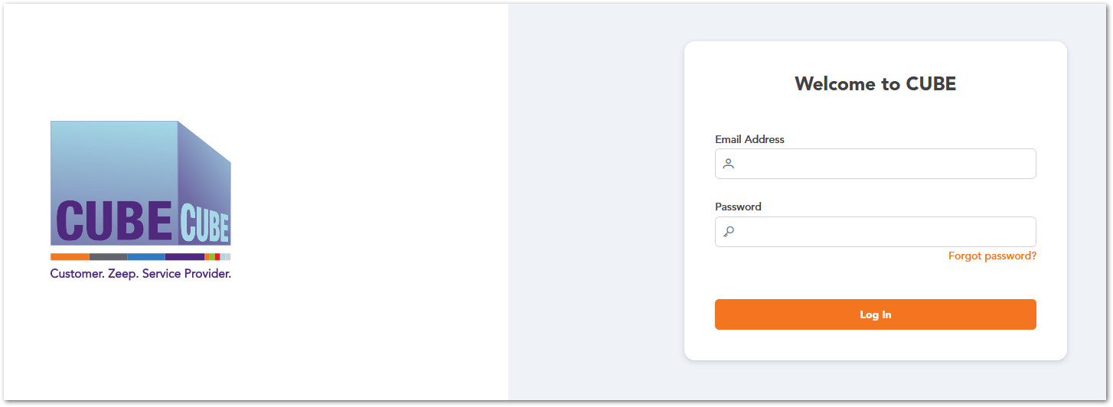

Forgot Password
The Forgot Password option allows users to recover access to their CUBE account if they are unable to log in due to a forgotten password. When this option is selected, the system prompts the user to enter the email address associated with their account. After submitting the request, the system sends a password recovery email containing instructions to reset the password.
Password Recovery Process
- On the Login Page, click Forgot Password.
- Enter the email address associated with your CUBE account.
- Click Send Recovery Mail.
- Check your email inbox for the password recovery message.
- Follow the instructions provided in the email to reset your password.
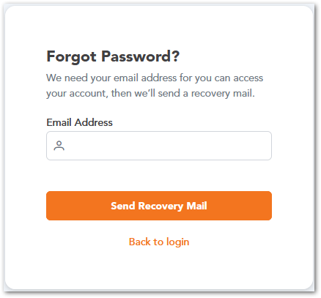
After completing the password reset process, the user can return to the Login Page and access the CUBE platform using the newly created password.

CUSTOMERZ SECTION
The Customerz section centralizes all customer-related information and operations within the CUBE platform. It allows users to manage customer profiles, contacts, service locations, and financial configurations such as billing preferences and transactions. This section serves as the foundation for linking customers to services, sites, and operational activities. It ensures accurate customer data management across the system.

Customers
This module displays a list of all customer records with key details such as name, contact information, and company. Users can search, filter, and manage records, as well as create new customers. This is the main entry point for customer management.
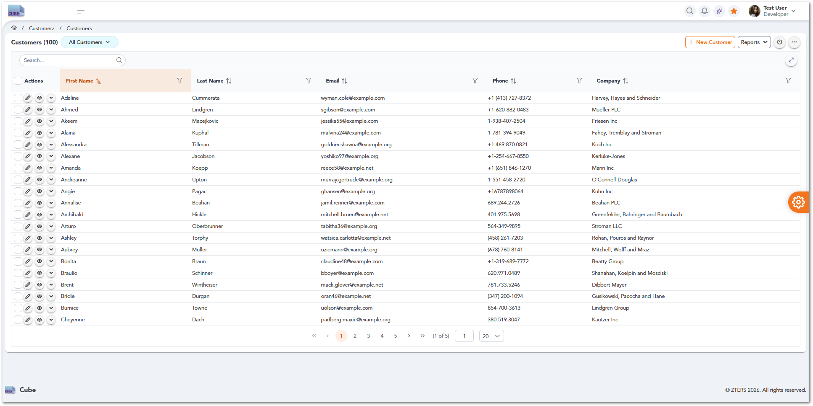

Customer Contacts
This module manages individual contacts associated with each customer account. This section is expected to store contact details such as names, roles, emails, and phone numbers, enabling effective communication and coordination with customer stakeholders. Contacts are typically linked to specific customer records.

Sites
This module manages service locations associated with customers. This section allows users to organize and track where services are delivered. It ensures operations are tied to the correct physical location.

Reviews
This module provides access to customer feedback and service evaluations. This section helps monitor service quality and identify improvement areas. It supports visibility in customer satisfaction.

CC Transactions
This module tracks credit card transactions linked to customer accounts. This includes payment activity and transaction status. It supports financial tracking and transparency.

Credit Limit Requests
This module manages requests related to customer credit limits. Users can review, approve, or update credit capacity. It supports financial control and risk management.

Accounting Inquiries
This module handles billing-related questions and financial issues from customers. This section supports tracking and resolving accounting concerns. It improves coordination between teams.

Billing Preferences
This module defines how customers are billed, including invoicing methods and payment preferences. This ensures billing aligns with customer agreements. It supports flexible financial operations.

SALEZ SECTION
The Salez section focuses on managing the commercial and transactional aspects of the platform. It includes tools for handling products, service tickets, line items, and invoicing processes. Users can track pricing, manage assets, and monitor financial interactions related to sales. This section supports the full lifecycle of service transactions from creation to billing.

Products
This module manages the catalog of products and services available in the system. It allows users to define product details, pricing, and availability. It serves as the foundation for sales and service transactions.

Toilets
Manage portable toilet services, including standard units, specialty options, and servicing schedules.

Roll-offs
Handle temporary dumpster rentals for waste removal, typically used for construction and cleanup projects.

Containers
Manage storage container rentals for on-site storage needs, including delivery, pickup, and duration.

Fencing
Configure temporary fencing solutions for job sites, events, or restricted areas.

Front Loads
Manage scheduled waste collection services using front-load dumpsters for ongoing commercial use.

Equipment Rentals
Handle rentals of additional equipment such as machinery or support tools required for job sites.

Perm Roll-off
Manage permanent roll-off dumpster services for long-term or recurring waste management needs.

Grease Trap
Handle grease trap cleaning and maintenance services, typically for restaurants and commercial kitchens.

Other Services
Capture and manage miscellaneous services that do not fall under standard product categories.

Service Tickets
This module manages service tickets representing customer requests or operational tasks. It allows users to track the lifecycle of a service from creation to completion. It is central to managing service execution.

Line Items
This module manages individual items within service tickets, including quantities, pricing, and service details. It provides a detailed breakdown of services and charges. It ensures accuracy in billing and configuration.

Invoices
This module manages customer invoices, including creation, tracking, and status updates. It allows users to monitor billing and payment activity. It supports the financial lifecycle of transactions.

AP Hub
This module manages accounts payable processes, including Service Provider payments and financial reconciliation. It supports tracking outgoing payments. It ensures financial operations are properly recorded.

Pricing History
This module provides access to historical pricing data for products and services. It allows users to track changes over time. It supports auditing and pricing analysis.

Z Sight Monitors
This module provides visibility into operational and sales metrics through monitoring tools. It allows users to track system performance and activity. It supports data-driven decision-making.

Assets
This module manages assets associated with services, customers, or operations. It allows users to track asset details and assignments. It supports inventory and operational management.

OPERATIONZ SECTION
The Operationz section manages the execution and coordination of services within the platform. It includes tools for handling service providers, fulfillment processes, Service Provider interactions, and pricing configurations. Users can track operational activities, manage service availability, and ensure proper service delivery. This section is critical for aligning internal operations with external providers.

Service Providers
The Service Providers module is the central place for managing every service provider registered in CUBE. From a single list, users can find a provider, check its status at a glance, preview key details without leaving the page, and open the full record to review or update it.
To access the module, select Operationz → Service Providers from the left navigation panel. CUBE opens the Service Providers list, which shows all provider records in a searchable, sortable table.
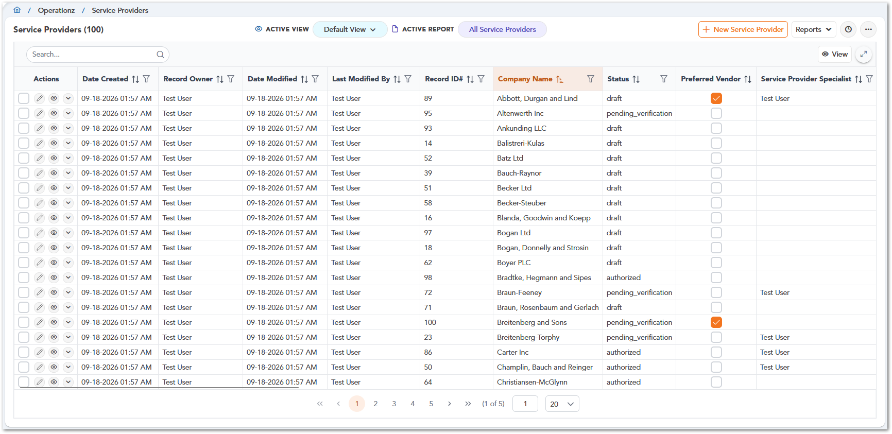

Page Header
The page header shows the total number of service providers, for example Service Providers (100), and gives quick access to views, reports, and record creation.
Option | Design | Description
Active View |  | Selects the table view used to display the list, such as Default View. Views control which columns, filters, and sorting are applied.
Active Report |  | Shows the report currently applied to the list, such as All Service Providers.
New Service Provider |  | Opens the form for creating a new service provider record.
Reports | 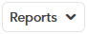 | Opens the Reports menu, where users can select a shared report or create a new one.
Recents |  | Displays the service provider records the user has accessed recently, so they can reopen them without searching the list.
More options (…) |  | Provides additional options, such as View Summary, Export CSV, and Print.

Note: For step-by-step instructions on creating table views and custom reports, see the Overall System Functionalities section.

Service Providers Table
The table lists one service provider per row. Users can narrow the list with the Search bar, sort any column with the arrow icons, and filter results with the funnel icon next to each column name. The View button lets users show or hide columns, and the expand icon in the upper-right corner opens the table in full-screen mode. The default view includes the following columns:
Column | Description
Date Created | Date and time the provider record was created.
Record Owner | User who owns the provider record.
Date Modified | Date and time of the most recent change to the record.
Last Modified By | User who made the most recent change.
Record ID# | Unique identifier assigned to the provider in CUBE.
Company Name | Name of the service provider company.
Status | Current lifecycle status of the provider, such as draft, pending_verification, or authorized.
Preferred Vendor | Indicates whether the provider is marked as a preferred vendor.
Service Provider Specialist | User assigned as the specialist responsible for the provider.
Phone Number | Provider’s main phone number.
Email | Provider’s main email address.
Preferred Communication | Provider’s preferred method of contact.
Address | Provider’s street address.
City | City where the provider is located.
State | State where the provider is located.
Zip | Provider’s postal code.
Website | Provider’s website.
Payment Terms | Payment terms agreed with the provider.
ZTERS Arranged Payment Method | Payment method arranged by ZTERS for paying the provider.
MSA | Indicates whether the provider has a Master Service Agreement (MSA).
Does this hauler provide tonnage information? | Indicates whether the provider reports tonnage information.
Willing to do same day/expedited deliveries? | Indicates whether the provider accepts same-day or expedited deliveries.

Note: The columns shown in the table depend on the selected Active View. Users can add, remove, or reorder columns at any time by editing the view.

Tip: Need to find a provider fast? Type part of the company name or Record ID in the Search bar. The table updates automatically as you type.

At the bottom of the table, pagination controls let users move between pages, jump directly to a specific page, and choose how many records to display per page.
For more details on searching, sorting, filtering, and selecting multiple records, see section 12 Overall System Functionalities.

Row Actions
The Actions column gives quick access to the most common options for each provider record.
Option | Design | Description
Select |  | Selects the record so bulk actions can be applied to it.
Edit |  | Opens the provider record in edit mode so users can update its information.
View |  | Opens the provider record in read-only mode so users can review its details without making changes.
Expand / Collapse |  | Shows or hides the provider summary panel directly below the row.

Info: Edit and View open the same record page. The only difference is that View is read-only.

Service Provider Summary
The Service Provider Summary panel offers a quick snapshot of a provider without leaving the list. To open it, select the Expand icon in the Actions column. The panel appears directly below the selected row, and selecting the icon again collapses it.
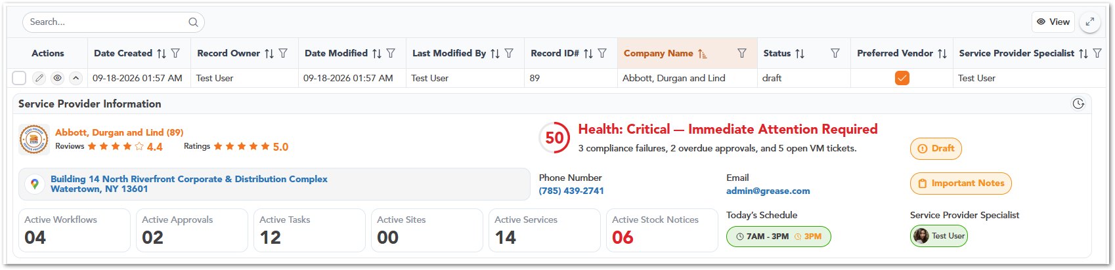
The panel, titled Service Provider Information, groups the provider’s most important details into a single view:
Element | Description
Provider Name and Record ID | Company name of the provider, followed by its Record ID.
Reviews and Ratings | Average review score and average rating, shown as starts and a numeric value.
Health Score | Numeric score with a status message, for example Health: Critical – Immediate Attention Required. A short summary below the message explains what is affecting the score, such as compliance failures, overdue approvals, or open VM tickets.
Address | Provider’s primary address.
Phone Number and Email | Main contact details for the provider.
Status | Current lifecycle status of the provider, for example Draft.
Important Notes | Opens the important notes recorded for the provider.
Activity Counters | Number of active workflows, approvals, tasks, sites, services, and stock notices associated with the provider.
Today’s Schedule | Provider’s operating hours for the current day, along with the order cutoff time.
Service Provider Specialist | User assigned as the provider’s specialist.

Tip: Use the summary panel to triage providers quickly. A low Health Score or a high number of active stock notices are good signals that a provider needs attention before you assign new work.

Note: The summary panel is for reference only. To update any of this information, open the record using the Edit option.

Service Provider Contacts
The Service Provider Contacts section allows users to view and manage contact information associated with Service Providers in CUBE. It provides a centralized table containing contact names, contact types, phone numbers, email addresses, preferred communication methods, and other relevant information.
Users can search, sort, and filter contact records directly from the table. The section also provides options to create new contacts, customize table views, access shared reports, and review individual contact records through the available row-level actions.
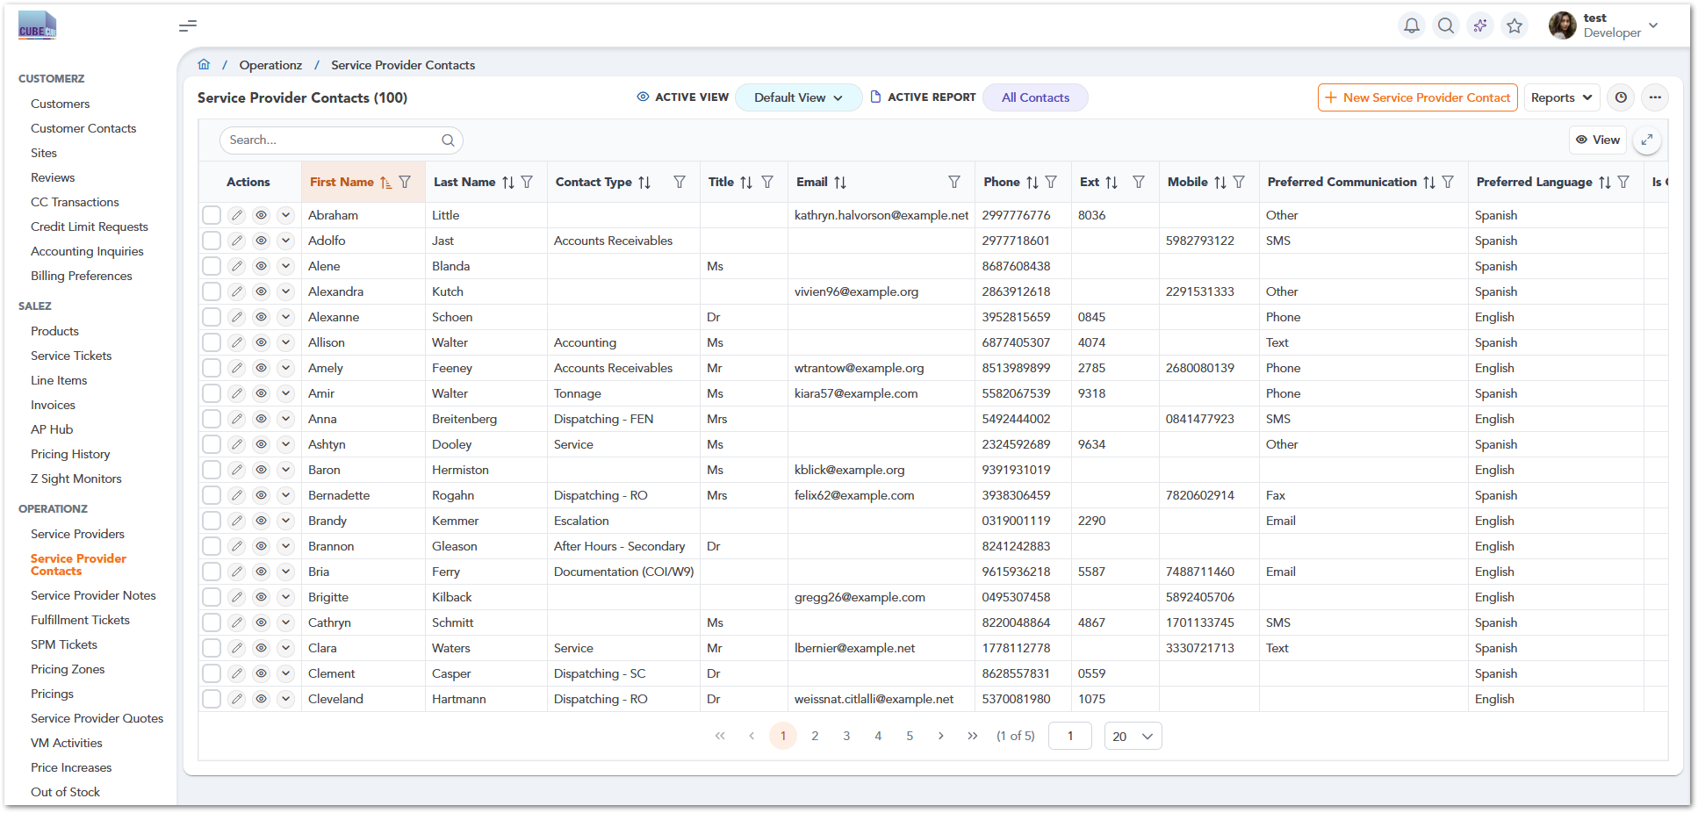

Creating a Service Provider Contact
To create a contact, select New Service Provider Contact from the upper-right corner of the Service Provider Contacts page. CUBE opens the contact creation form, where users can enter personal information, communication preferences, related Service Provider information, and address details. The form is organized into two main areas:
- Contact Information: Contains the contact's name, title, contact type, phone numbers, email address, preferred contact method, language, related Service Provider, and address information.
- User Information: Displays record-related information, including Created By, Last Modified By, Record Owner, and Service Provider Specialist.
Note: Fields marked with an asterisk (*) are required. Once the necessary information has been entered, users can select Save to submit the contact record or Cancel to leave the form.

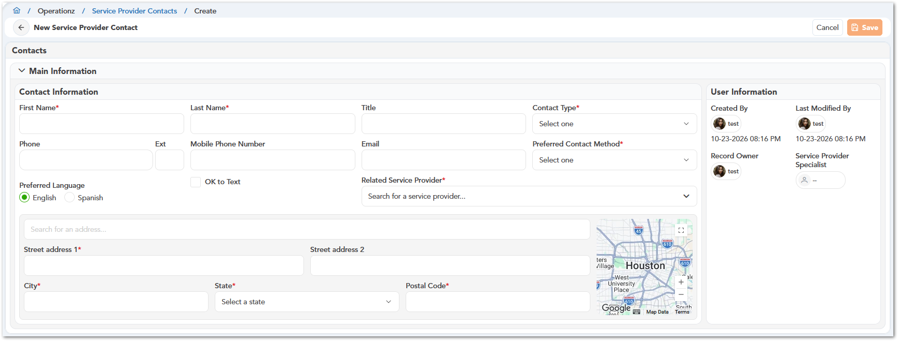

Contact Type and Preferred Contact Method
The Contact Type dropdown allows users to identify the contact's role or responsibility within the Service Provider organization. Available options include Sales, Accounts Receivables, Dispatching (PT, RO, SC, and FEN), Service, Documentation (COI/W9), Escalation, After Hours contacts, Permanent Sales, Tonnage, PSP Contact, and Accounting.
The Preferred Contact Method dropdown specifies how the contact prefers to be reached. Available options include Phone, Email, Text, SMS, Portal, Fax, and Other.
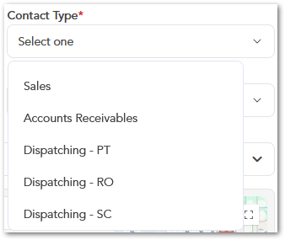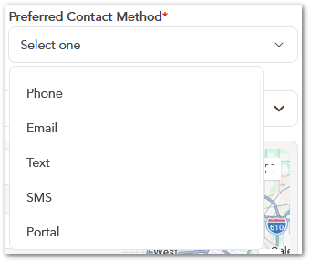

Contact Record Actions
The Actions column provides options for interacting with individual contact records. Users can select the pencil icon to edit a contact, the eye icon to view its information, or the expand icon to access additional record details.
The table also includes checkboxes for selecting records, as well as search, column sorting, filtering, and pagination controls to help users navigate larger contact lists.

Additional Table Controls
The Service Provider Contacts page includes additional controls for navigating and reviewing the table. Users can select the available View option, expand the table display, and navigate between pages using the pagination controls at the bottom.
These controls support reviewing contact information without changing the underlying contact records.

Service Provider Notes
The Service Provider Notes section allows users to create, view, and manage notes associated with Service Providers in CUBE. These notes help maintain a record of important provider-related information, including operational comments, documentation requirements, pricing information, and other relevant details.
The main page displays a table containing the note's creation date, record owner, modification date, last modified by, related Service Provider, note type, and note content. Users can search, sort, and filter the records to locate specific notes. The Actions column also provides options to edit, view, or expand individual records.
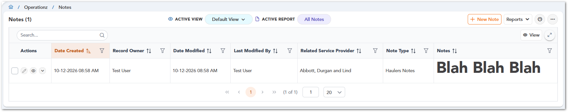

Creating a Service Provider Note
To create a note, select New Note from the upper-right corner of the Service Provider Notes page. CUBE opens the New Service Provider Note form, where users can specify the note type, enter the note content, and select the related Service Provider. The form contains the following fields:
Field | Description
Note Type | Selects the category used to classify the note.
Note | Provides a rich-text editor for entering and formatting note content, including text styles, lists, links, and images.
Related Service Provider | Associates the note with a specific Service Provider record.

Note: Fields marked with an asterisk (*) are required. Users can select Save to submit the note or Cancel to leave the form.

The User Information panel displays additional record information, including Created By, Last Modified By, Record Owner, and Service Provider Specialist.
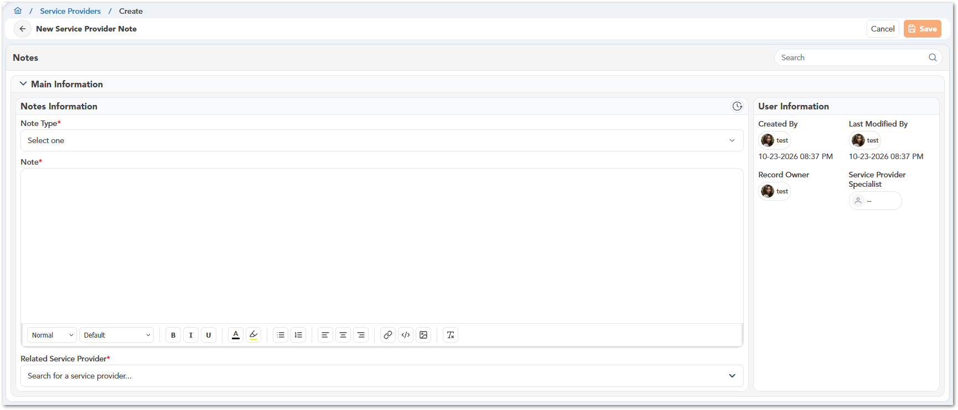

Note Types
The Note Type dropdown allows users to classify notes according to their purpose. The available categories shown in CUBE include:
Note Type | Description
Haulers Notes | General notes related to Service Providers and their operations.
COI Notes | Notes associated with Certificate of Insurance documentation.
Insurance/W-9 Requested Notes | Records information related to insurance or W-9 documentation requests.
Pricing Notes | Notes related to Service Provider pricing information.
W9 Requested Notes | Notes concerning requests for W-9 tax documentation.

Selecting the appropriate note type helps distinguish different kinds of information associated with a Service Provider.
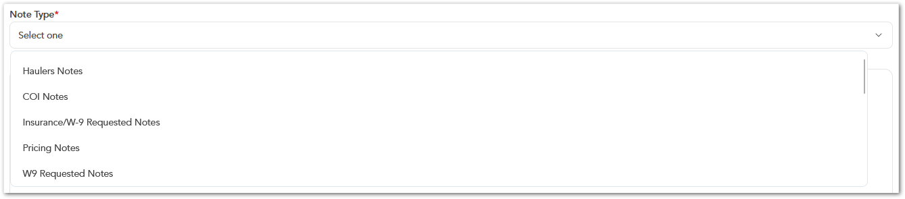

Fulfillment Tickets
This module manages tickets related to service fulfillment and execution. It allows users to track delivery, scheduling, and completion of services. It ensures customer requests are properly executed.

SPM Tickets
This module manages Service Provider management tickets used for coordination with service providers. It supports tracking communication and resolving operational issues. It helps align Service Provider-related workflows.

Pricing Zones
This module defines geographic or operational zones used for pricing calculations. It allows users to organize areas based on service coverage. It supports location-based pricing strategies.

Pricings
This module manages pricing structures, rates, and rules for services and products. It allows users to configure how pricing is applied. It supports flexible and accurate pricing management.

Service Provider Quotes
This module manages quotes submitted by service providers for service requests. It allows users to review and compare Service Provider pricing. It supports decision-making in service procurement.

SPM Activities
This module tracks activities related to Service Provider management operations. It provides visibility into interactions and updates with service providers. It supports monitoring of Service Provider workflows.

Price Increases
This module manages updates and adjustments to pricing. It allows users to track and apply approved price changes. It supports financial control and transparency.

Out of Stock
This module tracks products or services that are currently unavailable. It provides visibility into stock limitations. It supports operational planning and service availability.

Zip Codes
This module manages geographic areas where services are available. It allows users to associate locations with providers and pricing. It supports accurate service coverage configuration.

Service Provider Ratings
This module tracks and evaluates service provider performance. It allows users to review ratings and feedback. It supports quality control and Service Provider assessment.

Service Provider Business Hours
This module manages the availability schedules of service providers. It allows users to define working hours and service windows. It supports scheduling and operational planning.

ZEEPZ SECTION
The Zeepz section focuses on internal engagement and sales pipeline management. It includes tools for managing leads, employees, and recognition programs such as bonus points and badges. Users can track team participation and process reward redemptions. This section supports both operational engagement and sales-related activities.

Leads
This module manages potential customers and sales opportunities. It allows users to track lead information and progression. It supports pipeline management and conversion tracking.

Employees
This module manages internal employee records and related information. It allows users to maintain employee data within the system. It supports internal administration and tracking.

Bonus Points
This module manages the internal rewards system used to recognize employee contributions. It allows tracking and assigning points. It supports engagement and recognition initiatives.

Badges
This module manages recognition badges awarded to users. It allows creating and assigning badges based on achievements. It supports gamification and employee engagement.

ADMINISTRATORZ SECTION
The Administratorz section provides system configuration and control capabilities. It allows users to define codes, states, and system rules that govern workflows and data structure. This area supports internal administration, task management, and system customization. It ensures consistency and standardization across the platform.
Note: The Administratorz section is restricted by role-based access and only visible to admin users.

Products
This module manages the zters products and services. It ensures consistency across the system. It supports structured data management.

Product Codes
This module manages standardized codes used to identify products and services. It ensures consistency across the system. It supports structured data management.

Ticket Codes
This module defines codes used to classify and categorize tickets. It helps organize service requests and workflows. It supports better tracking and reporting.

States
This module manages system states used in workflows, such as statuses or process stages. It ensures consistency in process tracking. It supports workflow standardization.

Notes
This module manages internal notes associated with system records. It allows users to add contextual information or comments. It supports collaboration and traceability.

Service Provider Link
This module manages relationships between service providers and system entities. It ensures proper linkage across modules. It supports data consistency and integration.

Tasks
This module manages internal tasks assigned to users. It allows tracking of activities and responsibilities. It supports operational coordination.

Lead Sources
This module manages the origin of leads, such as campaigns or referrals. It helps track how leads are generated. It supports sales analysis and reporting.

Lead Parent
This module manages hierarchical relationships between leads or accounts. It allows linking related entities. It supports better organization of sales data.

Answered Phone Calls
This module tracks and logs phone call interactions. It provides visibility into communication activities. It supports customer interaction tracking.

USERZ SECTION
The Userz section is responsible for managing user access and system security. It includes tools for creating users, defining roles, assigning permissions, and organizing groups. This section ensures that users have appropriate access based on their responsibilities. It supports role-based access control and system governance.

Users
This module manages user accounts with access to the platform. It allows creating, editing, and maintaining user information. It supports overall user administration.
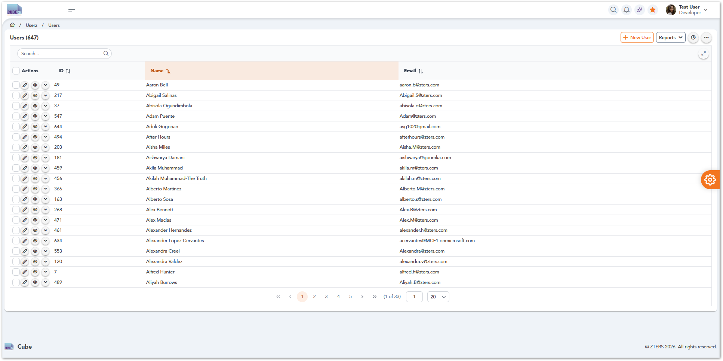

Roles
This module defines roles that determine user responsibilities and access levels. It allows grouping permissions based on job functions. It supports role-based access control.

Permissions
This module manages detailed access rights assigned to roles. It allows controlling what users can view or modify. It ensures system security and proper access control.

Groups
This module organizes users into groups for easier management. It allows assigning roles and permissions at a group level. It simplifies user administration.

DASHBOARDZ SECTION
The Dashboardz section provides access to the role-based and operational dashboards available in CUBE. These dashboards support different areas of the organization, including Customer Success, Account Management, Business Development, Service Provider Management, and operational reporting. Each dashboard presents information relevant to its intended role or business function.
Dashboards provide a consolidated view of key performance indicators, workload items, alerts, and operational information. Depending on the selected dashboard, users can monitor customer activity, sales and revenue performance, service provider operations, documentation compliance, accounting inquiries, ticket workloads, and other business metrics.
The section also includes a Role Select page, which provides access to specific role-based dashboards. Depending on the dashboard, users may find filters, timeframe selectors, charts, interactive tables, and other controls that allow them to review information at an individual, team, or organizational level.

Role Select
The Role Select page provides access to the role-based dashboards available within the Dashboardz section. Users can select the dashboard that matches their operational role, such as Customer Success Supervisor, Account Manager, Business Development Representative, BDR Team Lead, or Client Success Manager.
Each role card includes the role name, the corresponding dashboard name, and an Open Dashboard option. When users select an option, CUBE redirects them to the selected dashboard page within Dashboardz, where they can review the KPIs, tools, and information relevant to that role.
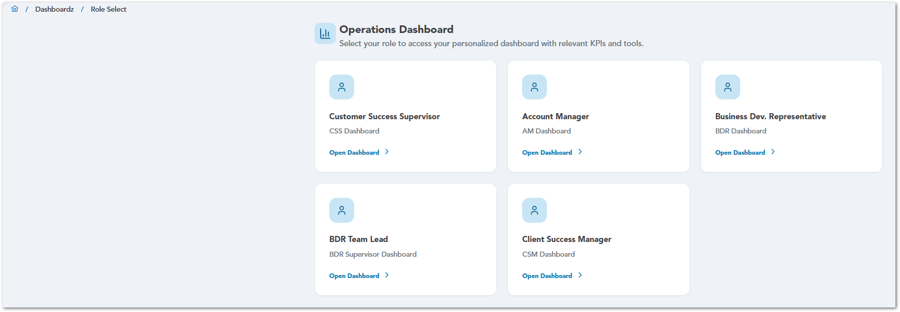

CSS Dashboard
The CSS Dashboard provides Customer Success Supervisors with a team-level view of revenue, customer status, account health, billing workload, accounting inquiries, and task activity. This dashboard helps supervisors monitor team performance, identify customer accounts that may require follow-up, and review operational or financial items that need attention.
Users can use the Team View selector to review dashboard information for the selected team. The dashboard also displays the last refresh time so users can identify when the displayed information was last updated.

CSS Dashboard Summary
The top section of the CSS Dashboard displays summary cards for key team indicators, including team revenue, average close ratio, average margin, and customer status. These cards provide a quick overview of the team’s current performance and customer base before users review the detailed dashboard sections below.
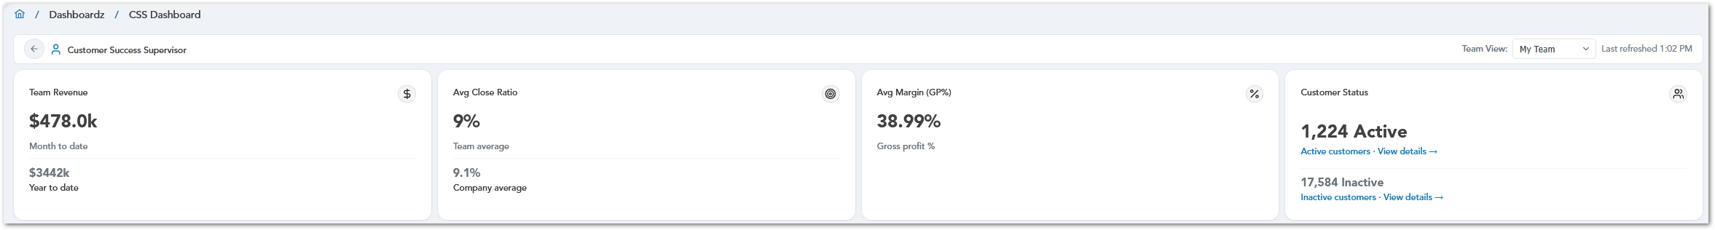

Revenue & Performance
The Revenue & Performance section helps Customer Success Supervisors review team revenue and margin performance. It includes charts for revenue by Account Manager, monthly revenue trends, and margin percentage by Account Manager. These visuals help users compare individual performance, monitor revenue movement over time, and identify margin results across the team.

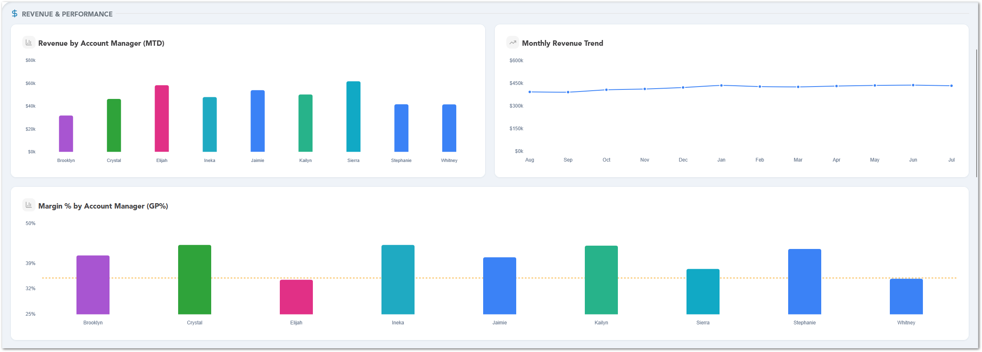

Close Ratio
The Close Ratio section helps Customer Success Supervisors review how effectively calls are being converted into customers. It includes charts that compare close ratio by Account Manager, show team performance against the company average, and break down close ratio by queue type. These visuals help users identify individual and team trends, compare performance across months, and review how different queue types contribute to conversion results.
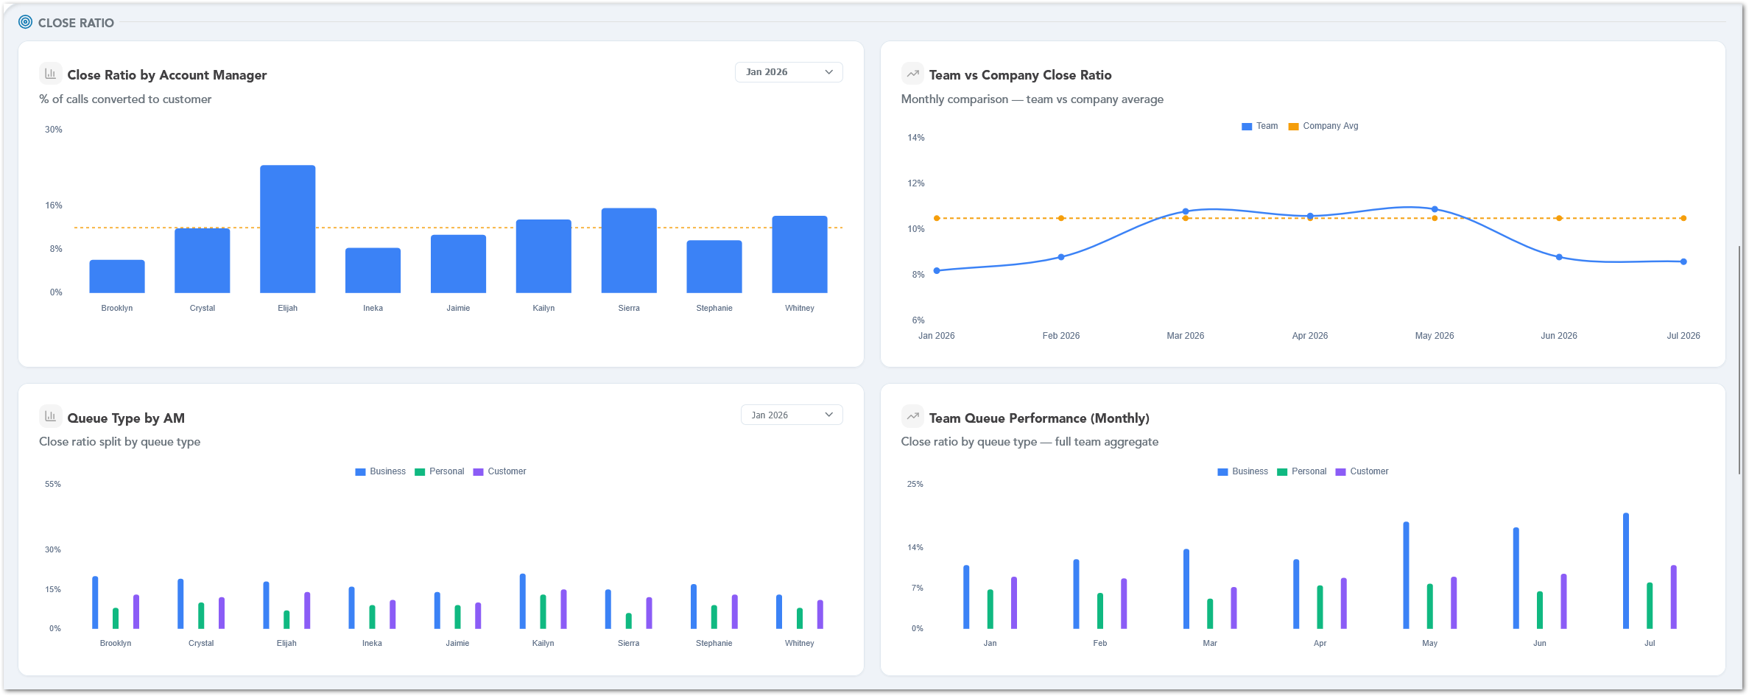

Tasks & Activities
The Tasks & Activities section helps Customer Success Supervisors review completed team activity for the selected period. It includes summary cards for check-ins, delivery follow-ups, removal follow-ups, and good reviews. The charts below provide a breakdown of task completion by Account Manager and show monthly task trends across the full team, helping users compare activity levels and identify how task volume changes over time.

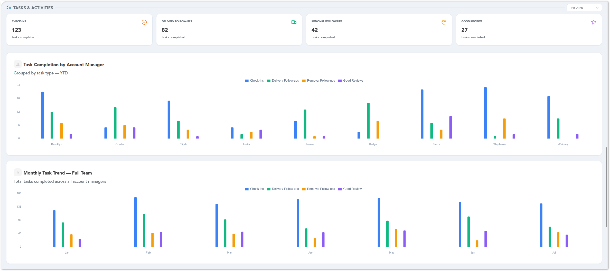

Account Health
The Account Health section highlights customer accounts that may require attention or follow-up. It displays counts for accounts on stop service, accounts that need re-engagement, accounts approaching their credit limit, and overdue accounting inquiries. Each card includes a View accounts option so users can open the related account list and review the affected records.
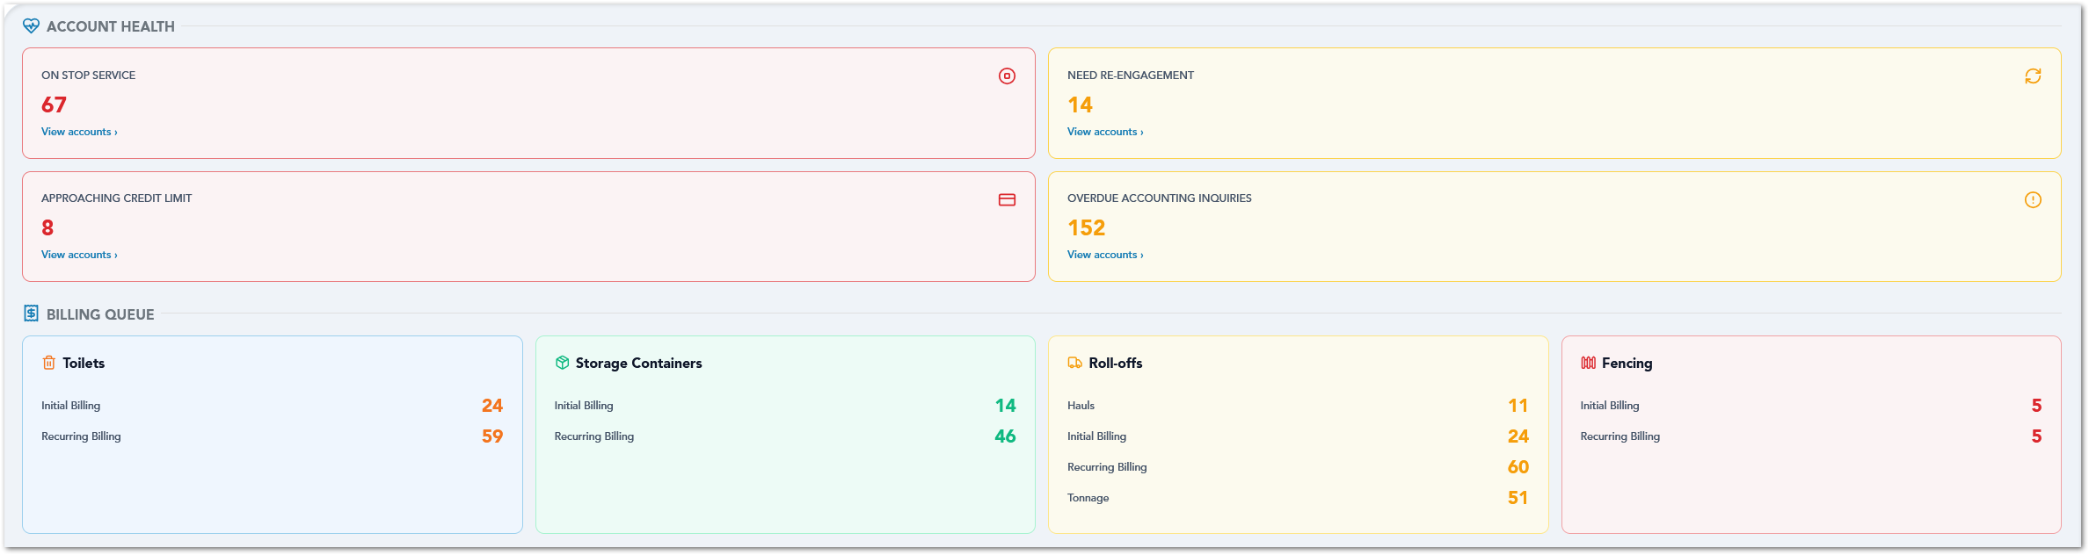

Billing Queue
The Billing Queue section summarizes pending billing items by product type, including Toilets, Storage Containers, Roll-offs, and Fencing. Each card displays the billing categories that require attention, such as initial billing, recurring billing, hauls, or tonnage, along with the current count for each category. This helps users quickly identify where billing follow-up is needed across different service lines.
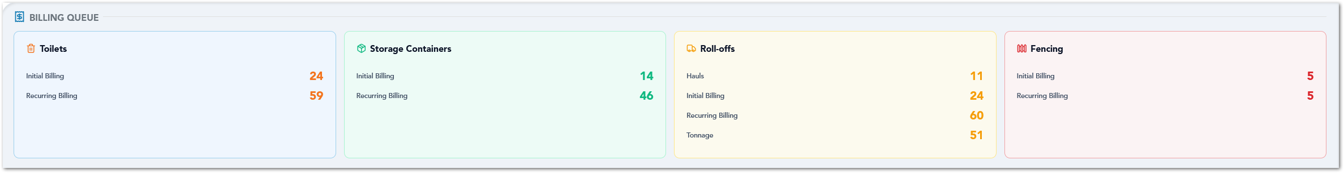

Accounting Inquiries
The Accounting Inquiries section helps Customer Success Supervisors review open accounting inquiries by age. It displays summary cards for inquiries that are 0–30 days, 31–60 days, and 60+ days old, along with the total number of open inquiries. The chart below shows inquiry aging by month created, using color coding to identify newer, aging, and older inquiries. Users can select a card or chart bar to view the related inquiry details.
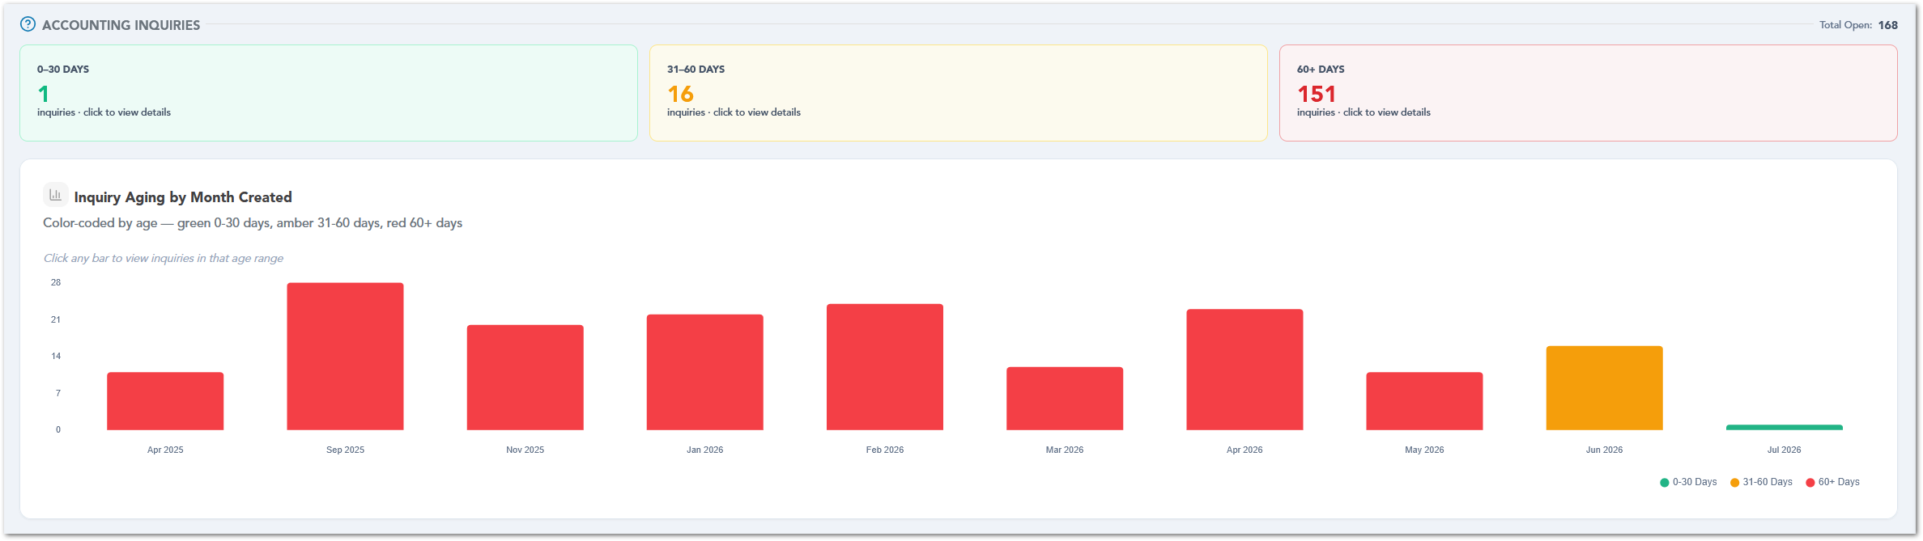

Aging & Financial Health
The Aging & Financial Health section summarizes past-due financial items by aging range and highlights accounts that may require follow-up. It displays aging cards for 0–30 days, 31–60 days, 61–90 days, and 90+ days, including the number of items and past-due amount for each range. The section also shows the total past-due amount, past-due accounts, overpayments, and unapplied credits, with View details options available for reviewing the related records.
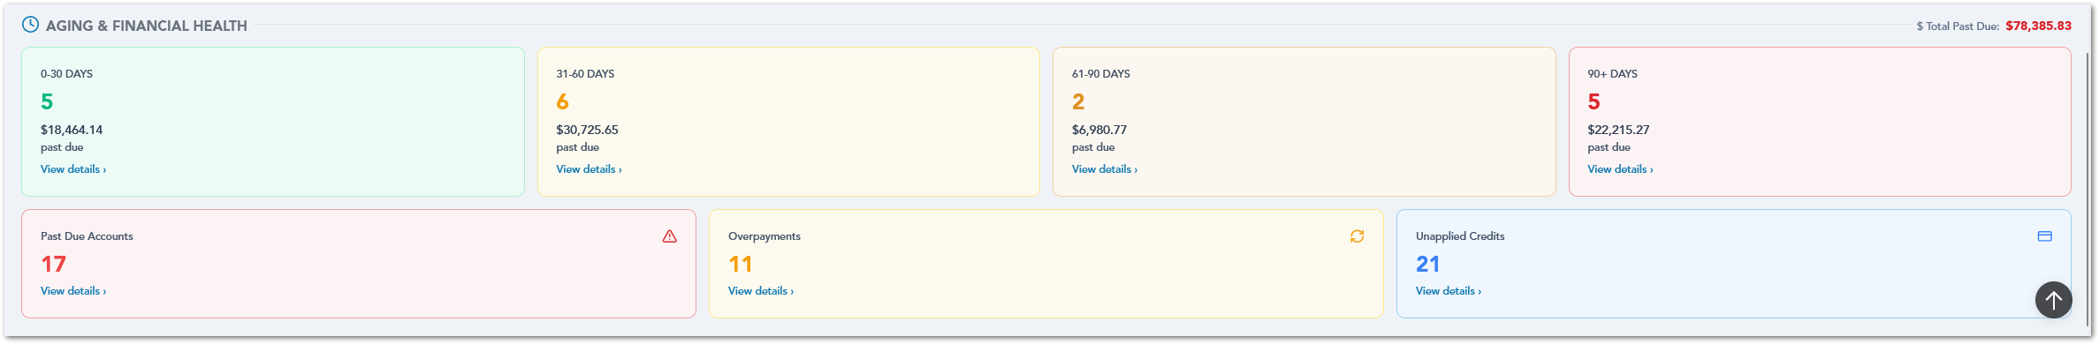

AM Dashboard
The AM Dashboard provides Account Managers with a focused view of their revenue, close ratio, gross profit margin, goal progress, and customer health indicators. This dashboard helps Account Managers monitor their individual performance, compare current results against company averages or targets, and identify customer accounts that may require follow-up.

Dashboard Summary
The top section of the AM Dashboard displays key performance indicators for the Account Manager, including month-to-date revenue, close ratio, and gross profit margin.
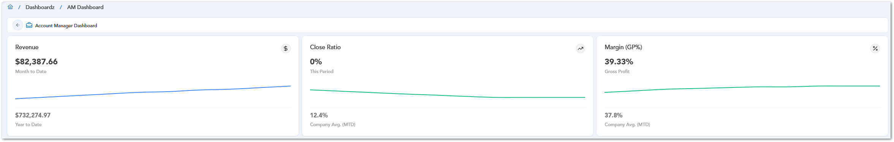

Revenue & Performance
The Goal vs Actual section provides a visual comparison between the Account Manager’s month-to-date (MTD) revenue and the established revenue targets. A gauge chart displays the current revenue amount and uses color-coded ranges to indicate performance against the defined thresholds. This allows users to quickly assess their progress toward revenue goals and identify whether their current results are below, approaching, or meeting the expected target.
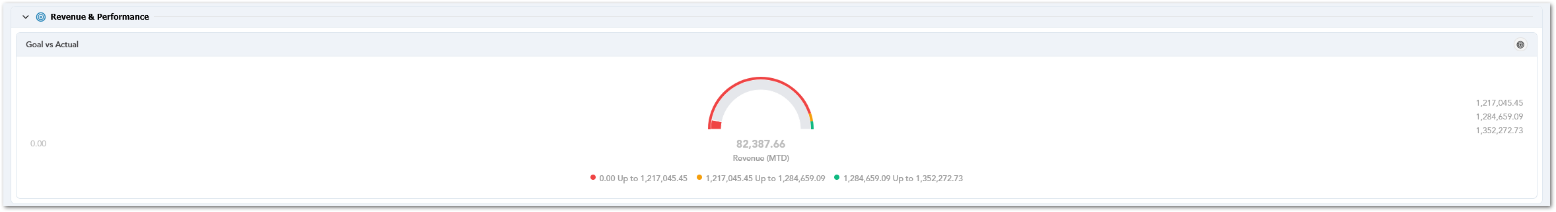

Customer Health
The Customer Health section summarizes the Account Manager’s customer base and highlights accounts that may require attention. It displays active customers, inactive customers, and re-engagement opportunities, with links to view the related account or contact details.

Active Customers Table
The Active Customers table lists the Account Manager’s currently active customer accounts. It includes key customer details such as customer number, customer name, company name, number of active sites, and primary email. Users can search, sort columns, and review active-site counts to quickly identify customers that are currently receiving service.

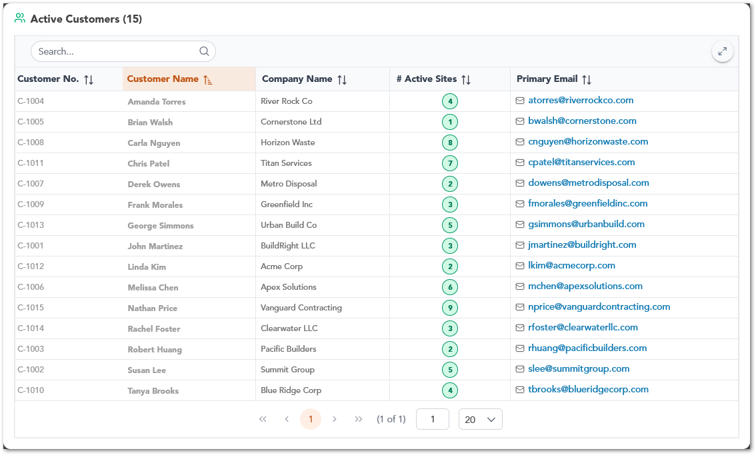

Inactive Customers — Re-engagement List Table
The Inactive Customers — Re-engagement List table displays inactive customer accounts that may be candidates for follow-up. It includes contact information, location, last product used, first sale date, last removal date, and historical revenue. This table helps users identify previous customers with potential re-engagement value and review the details needed to contact them again.
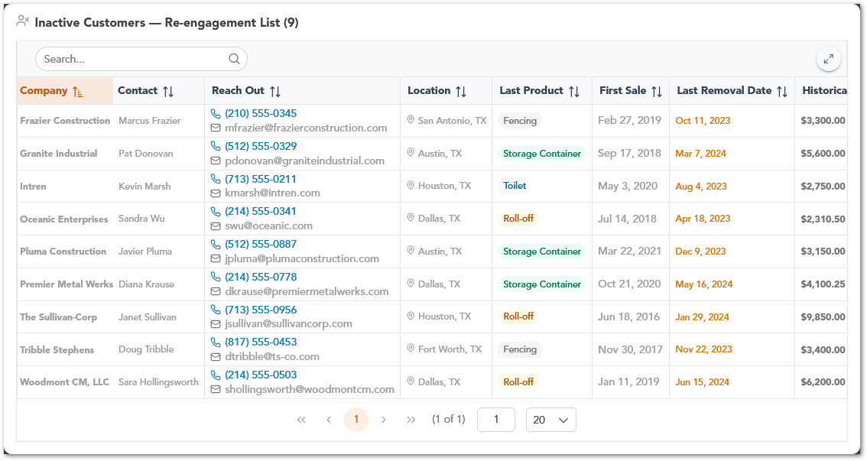

Fulfillment Snapshot
The Fulfillment Snapshot section summarizes the Account Manager’s fulfillment ticket workload. It displays the total number of tickets and groups them by status, including tickets created but not sent, tickets needing attention, assigned tickets, and fulfilled tickets that are not yet accepted. Each card includes a View Tickets option so users can open the related ticket list and review the records that require follow-up.

Created But Not Sent Tickets Table
The Created But Not Sent Tickets table lists fulfillment tickets that have been created but have not yet been dispatched. It includes the ticket ID, customer, product, service type, service address, created date, scheduled date, and current status. This helps Account Managers review draft tickets and identify items that still need to be sent.
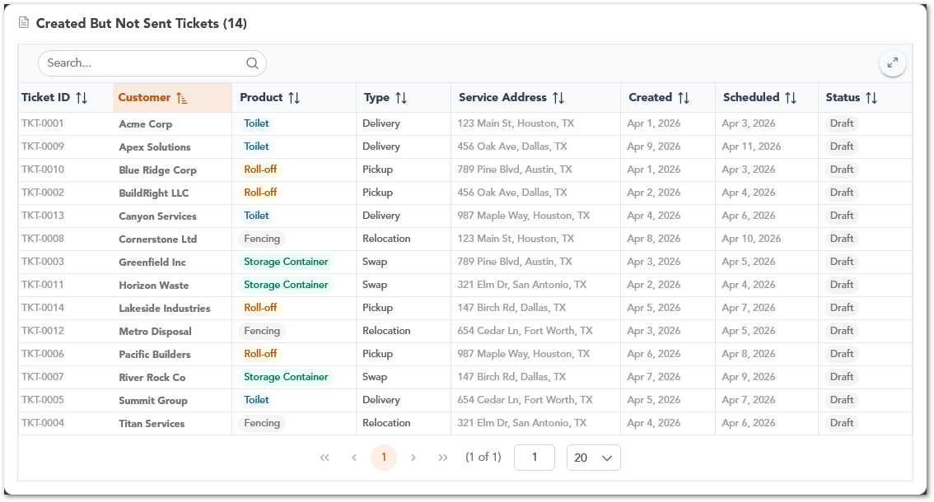

Tickets Needing Attention Table
The Tickets Needing Attention table displays fulfillment tickets that require immediate follow-up. The table includes the same key ticket details, such as customer, product, service address, created date, scheduled date, and status. Tickets in this view are marked as Action Required, helping users prioritize records that need review or correction.
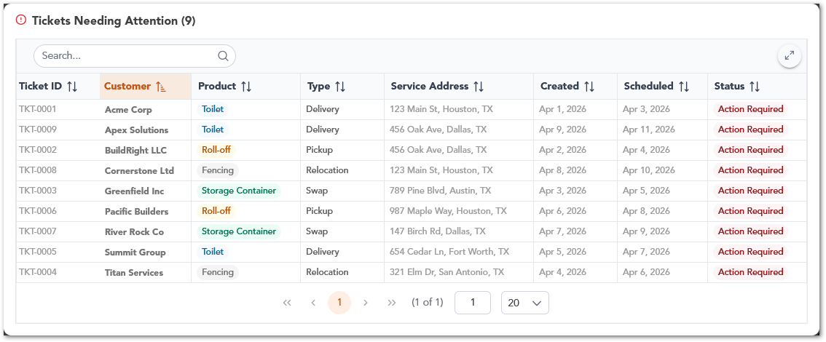

Assigned Tickets Table
The Assigned Tickets table lists fulfillment tickets that have already been assigned and are currently in progress. It helps Account Managers monitor active fulfillment work by showing the related customer, product, service type, service address, created date, scheduled date, and assigned status.
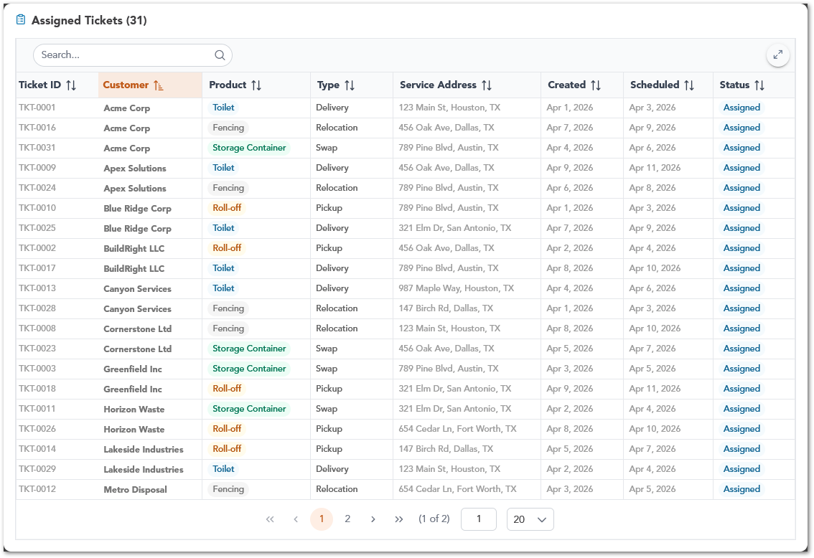

Fulfilled Not Accepted Tickets Table
The Fulfilled Not Accepted Tickets table shows tickets that have been completed but are still waiting for customer acceptance or sign-off. These records are marked as Pending Acceptance, allowing Account Managers to identify completed work that still requires final confirmation.
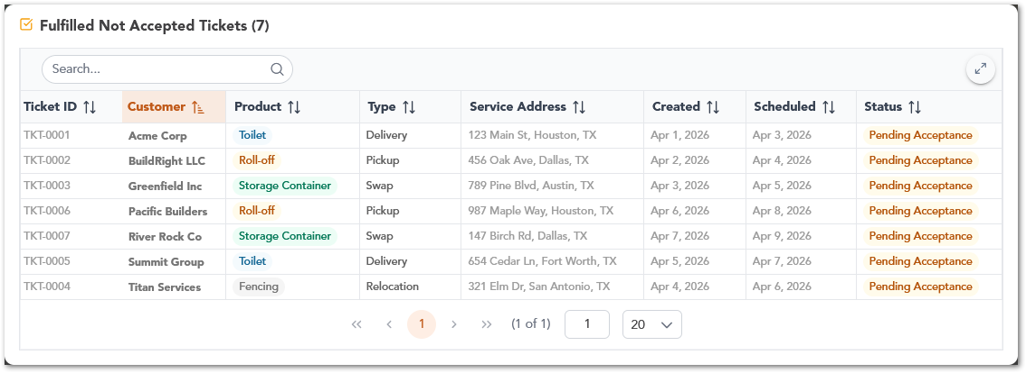

Revenue Leaderboard
The Revenue Leaderboard section ranks Account Managers by revenue for the selected period. The table shows each Account Manager’s rank, number of invoices, invoice total, credits, and final total. The current user is identified with a You label, making it easier to compare individual performance against other Account Managers.
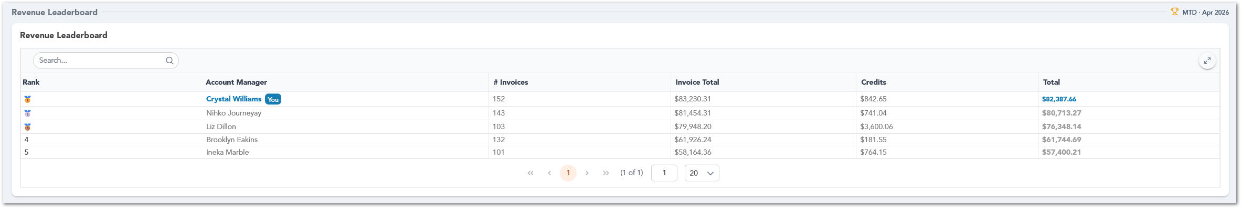

My Workflow
The My Workflow section summarizes the Account Manager’s open workflow items by product type, including Toilets, Storage Containers, Roll-offs, and Fencing. Each product card displays counts for workflow categories such as QIP, DR, BR, and TR, depending on the service line. Users can select any number in the card to drill down into the related records and review the items that require action.
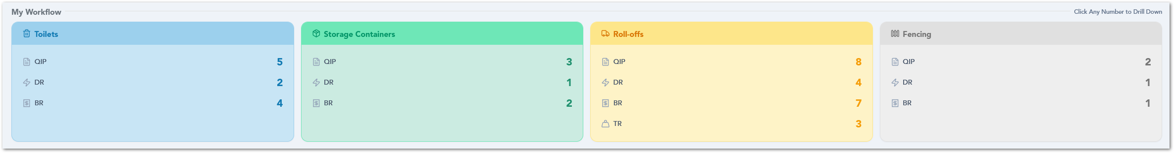

Accounting Inquiries
The Accounting Inquiries section summarizes the Account Manager’s open accounting inquiries by age range. It displays the total number of open inquiries and groups them into aging categories such as 0–30 days, 31–45 days, 46–60 days, and 60+ days. Below the summary cards, inquiries are organized by month created and can be expanded to display the related inquiry records, including inquiry ID, customer, issue, date created, and status. This helps users review inquiry volume, identify older items, and follow up on open accounting issues more easily.
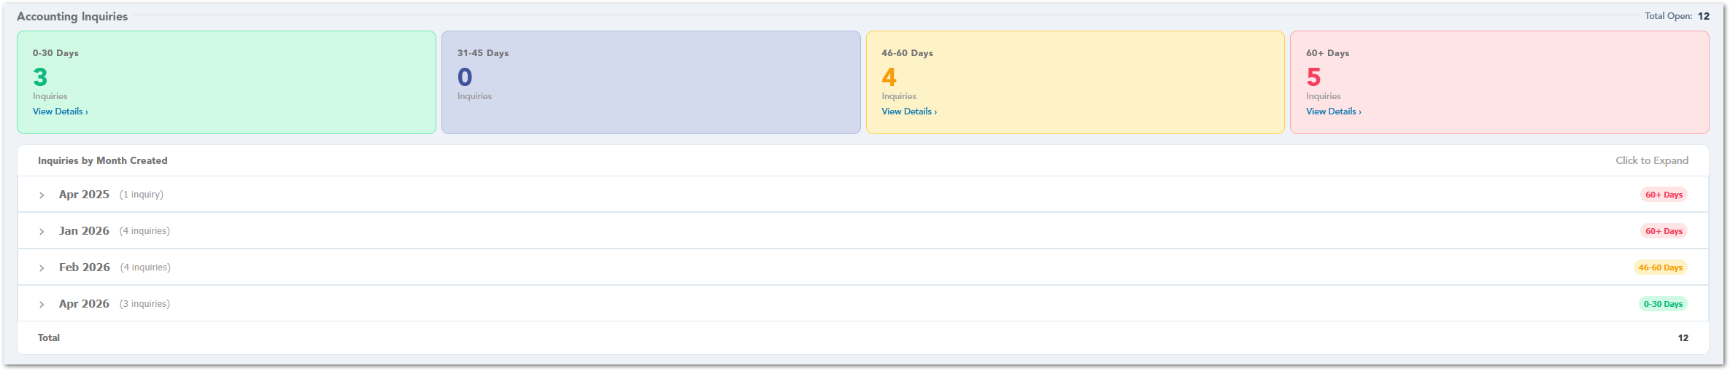

0–30 Days Inquiries Table
The 0–30 Days Inquiries table lists recently created accounting inquiries that are still open. It includes the inquiry ID, customer, issue, date created, and status, helping users review newer inquiries before they become older follow-up items.
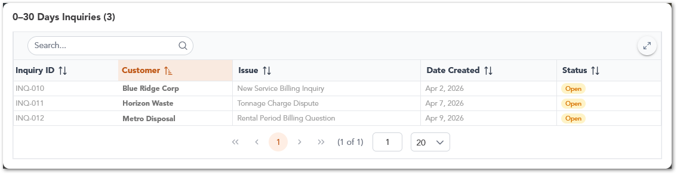

46–60 Days Inquiries Table
The 46–60 Days Inquiries table displays open accounting inquiries that have been unresolved for a longer period. These records may require closer review because they are approaching the oldest aging category. The table includes the inquiry ID, customer, issue, date created, and current status.
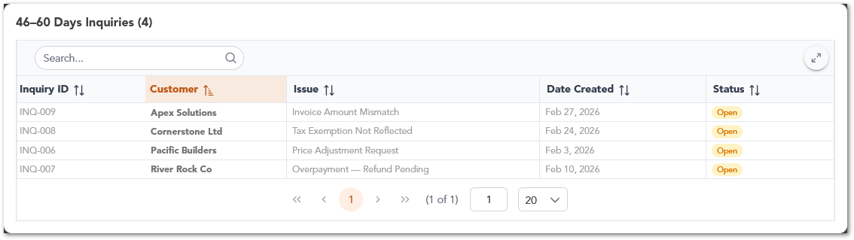

60+ Days Inquiries Table
The 60+ Days Inquiries table shows the oldest open accounting inquiries assigned to the Account Manager. These records are typically higher priority because they have remained open for more than 60 days. Users can review the inquiry ID, customer, issue, date created, and status to identify items that need follow-up or escalation.
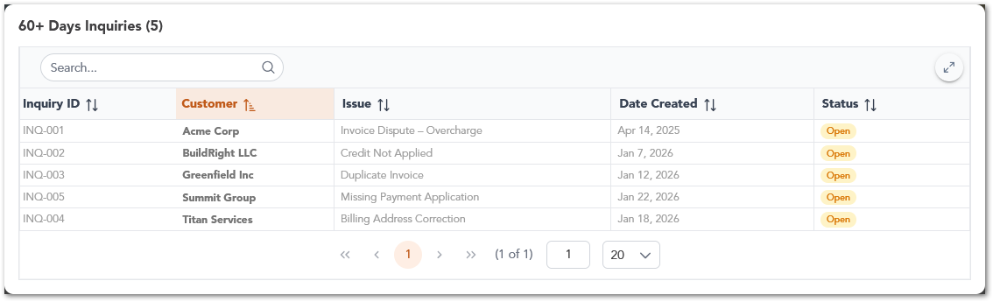

Money at Risk
The Money at Risk section highlights financial items that may require attention from the Account Manager. It displays the total exposed amount and groups risk areas into cards, including aging invoices over 30 days, top past-due accounts, accounts over or near the credit limit, accounts on stop service, and unapplied credits or overpayments. Each card includes a View Details option so users can review the related accounts or financial records.
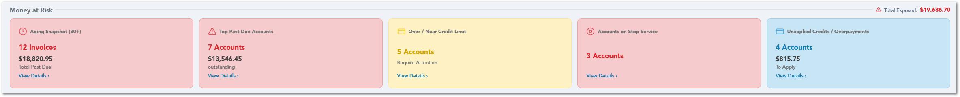

Aging Snapshot Table
The Aging Snapshot table breaks down accounts with invoices older than 30 days into aging buckets such as 31–60 days, 61–90 days, and 90+ days. It displays the customer, aging bucket, balance, credit status, record owner, last payment date, and open balance. This helps Account Managers review overdue balances and identify accounts that may require payment follow-up.
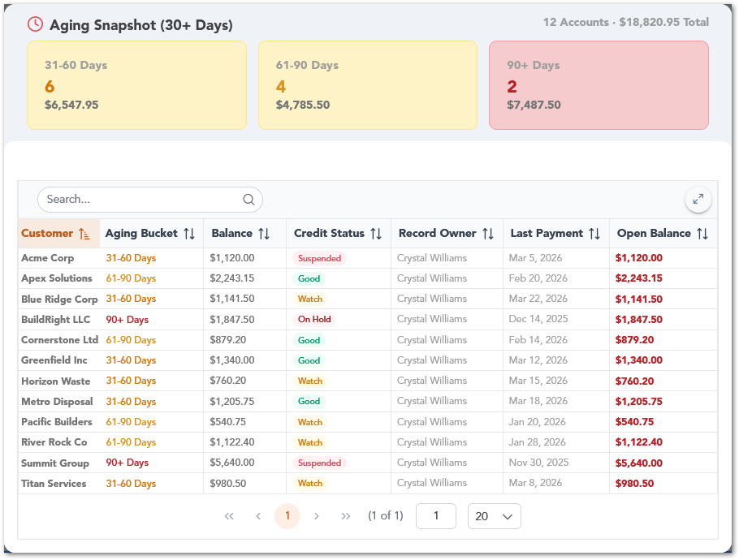

Top Past Due Accounts Table
The Top Past Due Accounts table lists customers with outstanding past-due balances. It includes the invoice date, number of days out, and amount due, helping Account Managers quickly identify the accounts with the most urgent overdue payments.
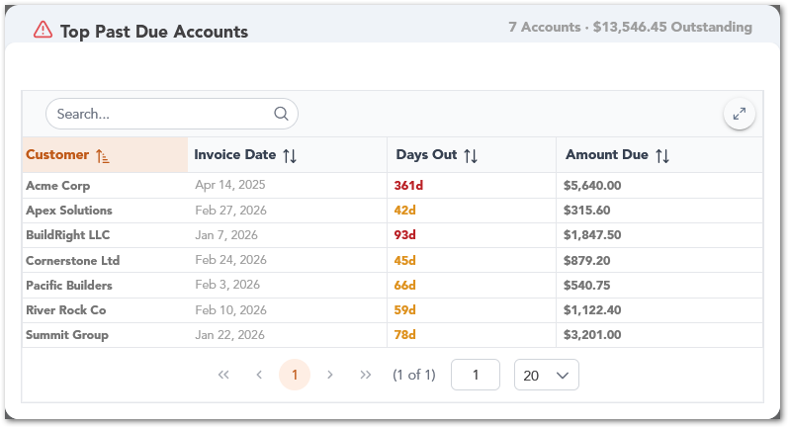

Over / Near Credit Limit Table
The Over / Near Credit Limit table shows customers that are approaching or exceeding their credit limit. It includes the customer name, company name, credit limit, credit status, and total open balance. This helps users identify accounts that may require review before additional services or billing activity continue.
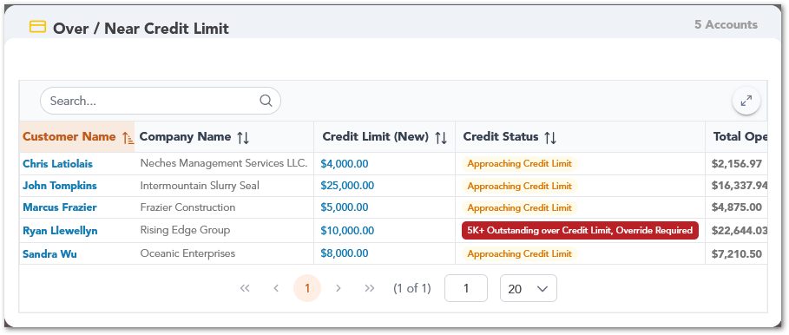

Accounts on Stop Service Table
The Accounts on Stop Service table lists customer accounts that are currently marked as stopped from service. It includes the date created, customer number, customer type, customer name, company name, primary email, and number of active sites. This helps Account Managers identify accounts where service activity may be restricted or paused.
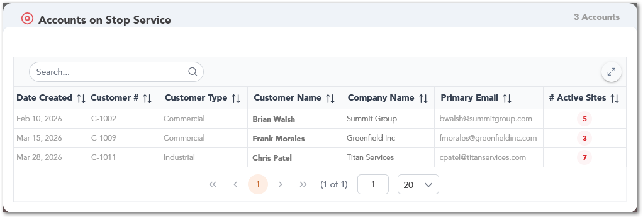

Unapplied Credits / Overpayments Table
The Unapplied Credits / Overpayments table displays customers with credits or overpayments that still need to be applied. It includes the customer, type, and amount, helping users identify available credits or overpayment balances that may require follow-up or reconciliation.
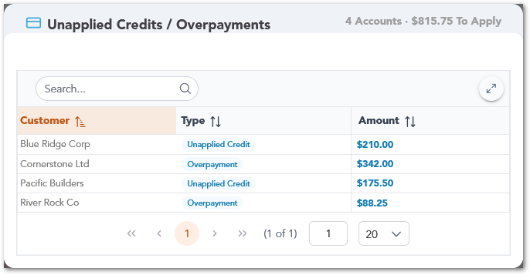

Open Tasks
The Open Tasks section summarizes the Account Manager’s pending task workload by task type. It displays the total number of open tasks and uses a bar chart to show categories such as confirm delivery, confirm removal, quote follow-up, check on services, inactive customer check-in, and researching. Users can select a bar to view the detailed task report for that task type.
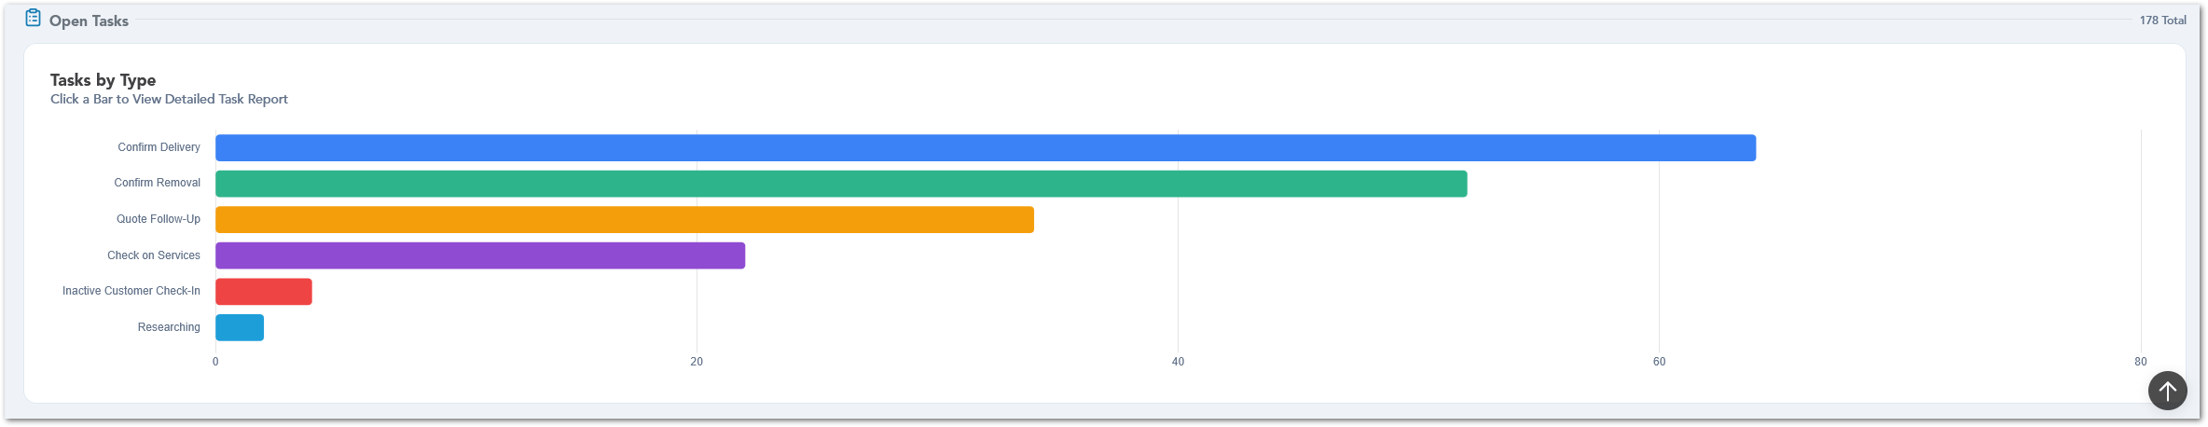

BDR Dashboard
The BDR Dashboard provides Business Development Representatives with a performance-focused view of their sales activity, revenue, close ratio, call activity, goal attainment, and evaluation score. The dashboard helps users monitor their progress across different timeframes, compare actual performance against targets, and identify whether their current results are on track or at risk.

Timeframe Filter
The BDR Dashboard includes a timeframe filter in the upper-right corner of the page. Users can switch between Daily, Weekly, Monthly, Quarterly, and YTD views to update the dashboard metrics based on the selected period. When a timeframe is selected, the KPI cards and related charts refresh to display the corresponding sales, revenue, close ratio, calls, goal attainment, and performance trends for that period.
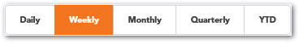

KPI Summary
The KPI Summary section displays the main performance indicators for the selected timeframe, including total sales, revenue, close ratio, total calls, evaluation score, and goal attainment. These cards give users a quick snapshot of their current performance and show whether key metrics are trending positively or need attention.
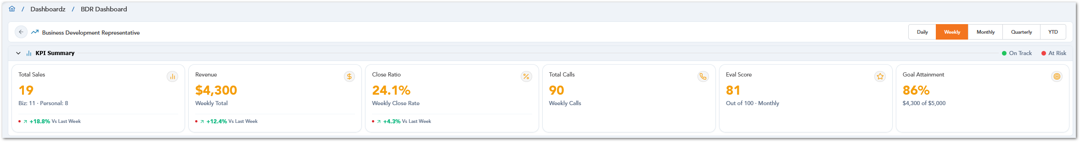
KPI | Description
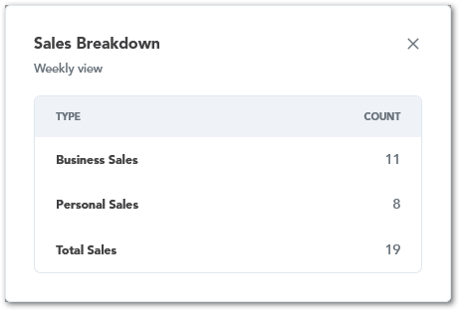 | The Sales Breakdown modal shows how total sales are divided between business sales and personal sales for the selected timeframe. It also displays the combined total sales count, helping users understand where their sales activity is coming from.
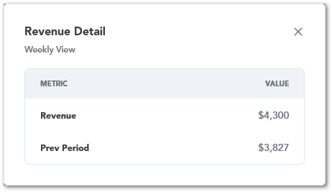 | The Revenue Detail modal shows the revenue generated during the selected timeframe and compares it with the previous period. This helps users quickly review whether revenue increased or decreased compared to the prior timeframe.
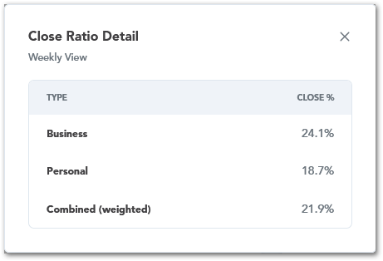 | The Close Ratio Detail modal breaks down close ratio performance by business, personal, and combined weighted results. This helps users understand how each queue type contributes to the overall close ratio.
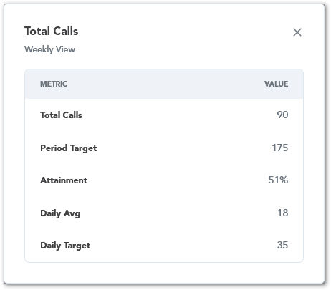 | The Total Calls modal shows call activity for the selected timeframe, including total calls, period target, attainment percentage, daily average, and daily target. This helps users compare call volume against the expected activity goal.
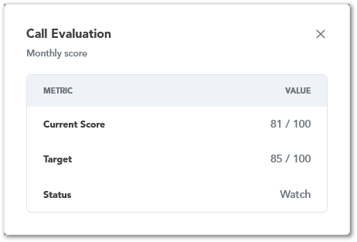 | The Call Evaluation modal shows the current evaluation score, target score, and status. This helps users review call quality performance and identify whether the score is meeting the expected threshold.
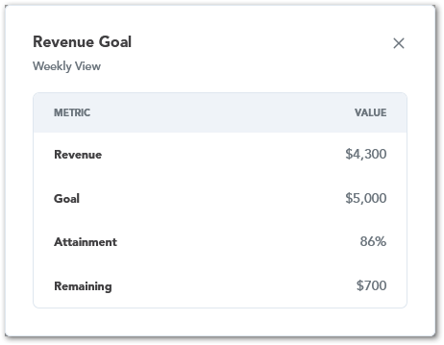 | The Revenue Goal modal compares current revenue against the goal for the selected timeframe. It displays the revenue amount, goal, attainment percentage, and remaining amount needed to reach the target.

Sales Performance
The Sales Performance section shows how sales are distributed between business and personal queues. It includes a Business vs Personal chart and a Sales Trend chart, allowing users to review daily or weekly sales activity and compare sales movement over time. Users can select points or bars in the charts to view additional details.
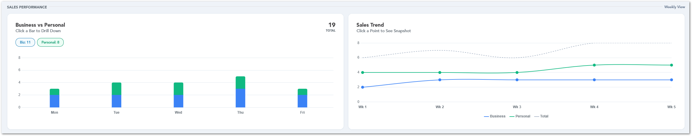

Close Ratio Performance
The Close Ratio Performance section helps users compare actual close ratio results against target values. It includes the overall close ratio, separate metrics for business and personal queues, and an Actual vs Target Close Ratio Trend chart. This helps users understand how conversion performance changes over time and whether they are meeting the expected close ratio target.
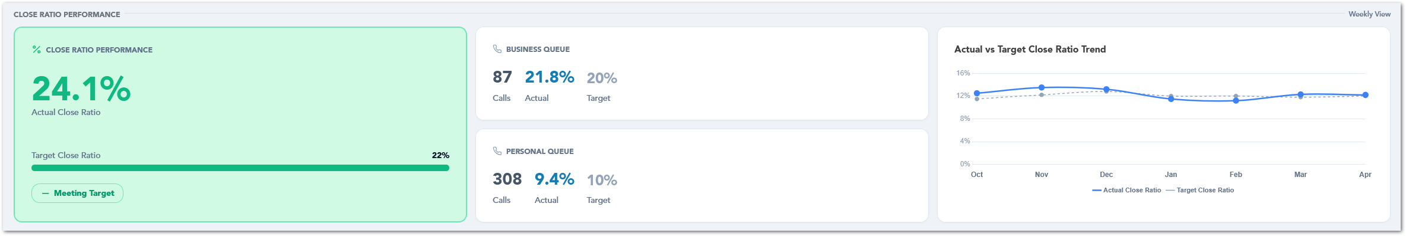

Call Activity
The Call Activity section tracks call volume for the selected period. It includes a Calls Over Time chart and summary cards for total calls, average calls per day, and target attainment. This helps users monitor calling activity, compare results against the target, and identify whether call volume is supporting the expected sales goals.
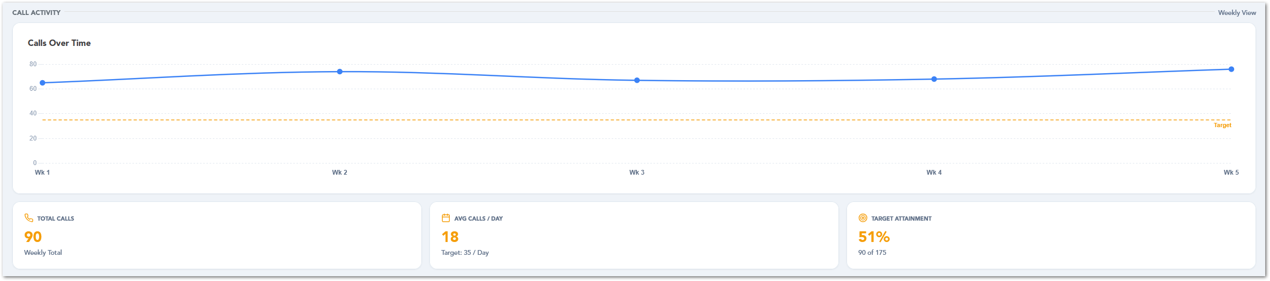
Call Activity | Description
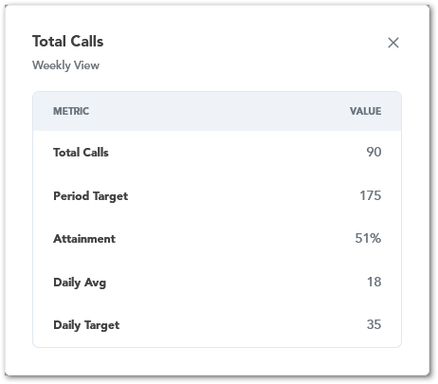 | The Total Calls modal shows the user’s call activity for the selected timeframe. It includes the total number of completed calls, the period target, attainment percentage, daily average, and daily target, helping users compare actual call volume against expected activity.
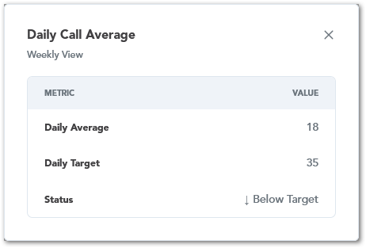 | The Daily Call Average modal compares the user’s average daily calls against the daily target for the selected timeframe. It also displays the current status, such as whether the user is below or meeting the expected target.
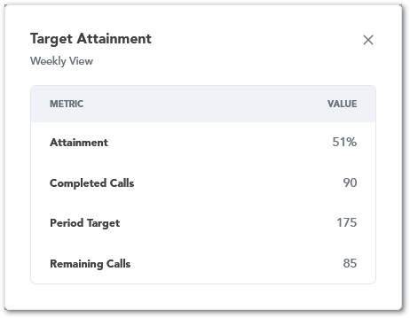 | The Target Attainment modal shows progress toward the call target for the selected timeframe. It includes the attainment percentage, completed calls, period target, and remaining calls needed to reach the goal.

Call Evaluation
The Call Evaluation section displays the latest evaluation score and the score trend over time. It shows whether the user’s score is above or below the defined threshold and provides a historical view of evaluation results. This helps users monitor call quality and identify whether performance is improving, stable, or below the expected standard.
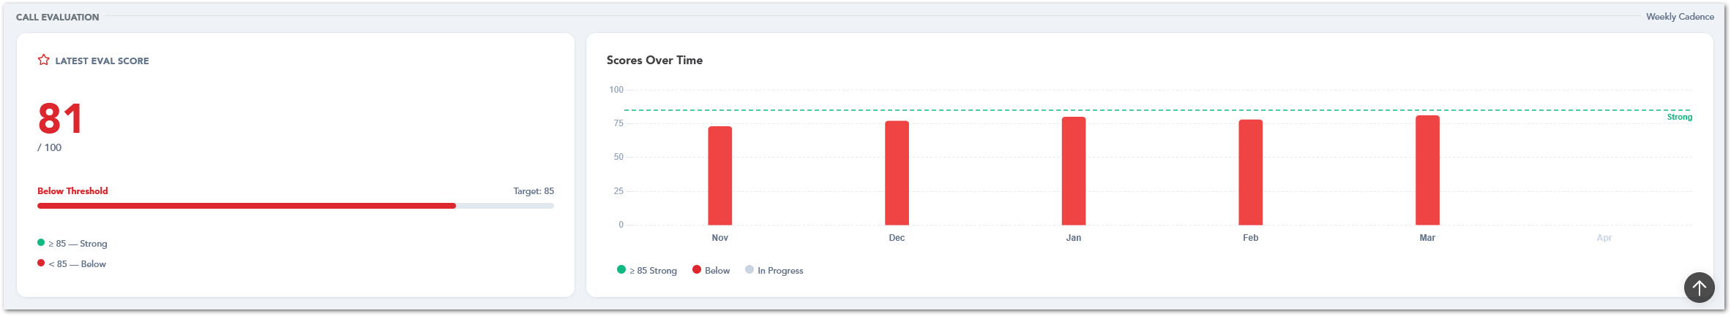

BDR Supervisor Dashboard
The BDR Supervisor Dashboard provides supervisors with a team-level view of BDR performance, including calls, close ratio, sales, revenue, call evaluation, and payout tracking. This dashboard helps supervisors monitor individual and team results, compare BDR performance across selected timeframes, and identify users who are meeting goals or may need coaching.
The dashboard includes filters for selecting a specific BDR or viewing all BDRs. It also includes timeframe options such as Daily, Weekly, Monthly, Quarterly, and YTD, which update the dashboard metrics and charts based on the selected period.

KPI Summary
The KPI Summary section displays the main team performance indicators for the selected timeframe. It includes total calls, average close ratio, total sales, total revenue, and average call evaluation score. These cards help supervisors quickly understand overall team performance and identify whether results are meeting goals or falling below expectations.
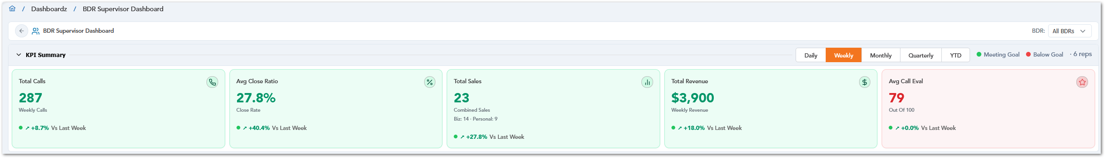
The BDR filter allows supervisors to view dashboard data for all BDRs or focus on a specific representative. When a BDR is selected, the dashboard updates the KPI cards, charts, and breakdowns to reflect that user’s performance.
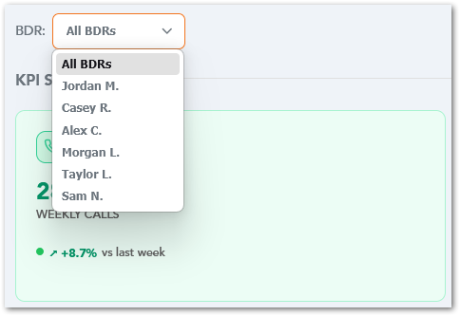
The KPI Summary cards can be opened to display additional detail for the selected timeframe and BDR filter. These detail modals provide a breakdown of the selected KPI, helping supervisors review how each metric is calculated across the team or by individual BDR.
KPI Summary | Description
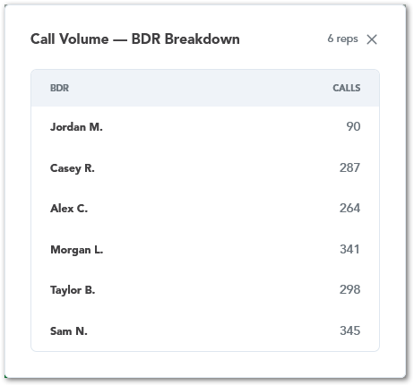 | The Call Volume, BDR Breakdown modal displays total calls by BDR for the selected timeframe. This helps supervisors compare calling activity across representatives and identify users with higher or lower call volume.
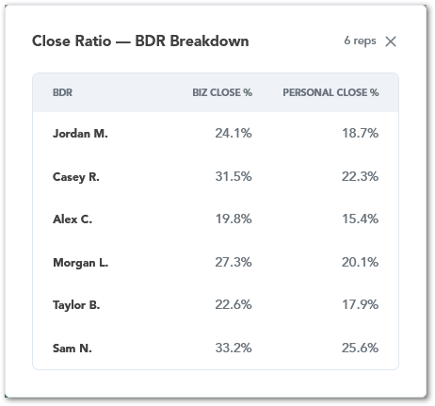 | The Close Ratio, BDR Breakdown modal compares business close percentage and personal close percentage for each BDR. This helps supervisors review conversion performance by queue type and identify where coaching may be needed.
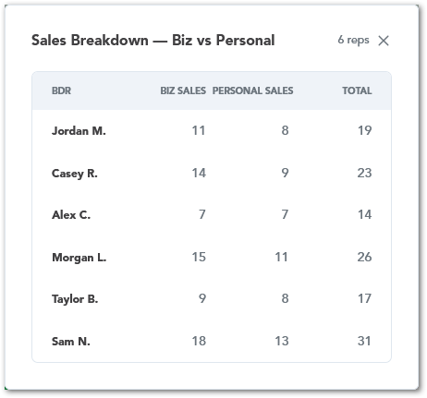 | The Sales Breakdown, Biz vs Personal modal shows business sales, personal sales, and total sales by BDR. This helps supervisors understand how each representative’s sales are distributed between business and personal queues.
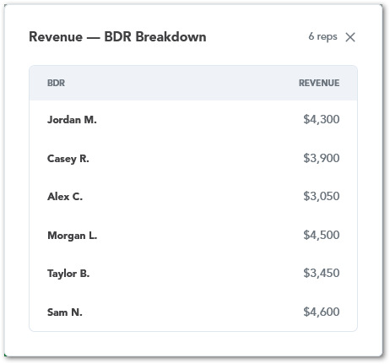 | The Revenue, BDR Breakdown modal displays revenue generated by each BDR for the selected timeframe. This helps supervisors compare revenue contribution across the team.
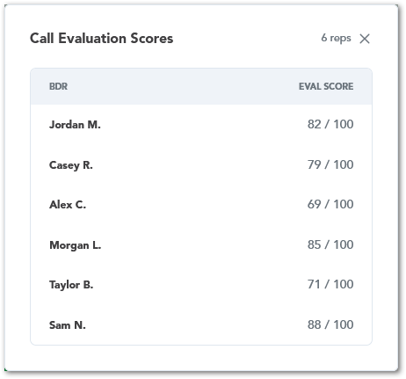 | The Call Evaluation Scores modal lists each BDR’s call evaluation score. This helps supervisors review call quality performance and identify representatives who are meeting or falling below evaluation expectations.

Team Performance Overview
The Team Performance Overview section compares BDR performance across the team. It includes a close ratio chart by BDR and BDR leaderboard that can rank users by close ratio, sales or revenue. This section helps supervisors identify top performers, compare individual results, and focus on specific BDRs for review or coaching.
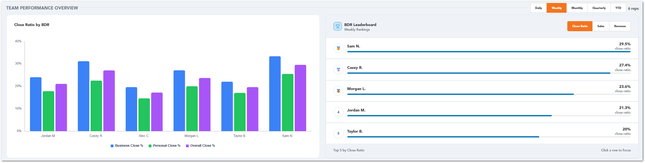

Team Performance Overview Interactions
In the Team Performance Overview section, users can select a specific BDR from the chart or leaderboard to focus the displayed information on that representative. When a BDR is selected, the chart updates to show that BDR’s business close percentage, personal close percentage, and overall close percentage.
The BDR Leaderboard can be sorted by Close Ratio, Sales, or Revenue. Selecting one of these options updates the ranking list so supervisors can compare representatives based on the selected performance metric. This helps supervisors quickly identify top performers and review which BDRs may need additional follow-up or coaching.

Call Activity
The Call Activity section tracks calling volume across the BDR team. It includes a total calls over time chart and a “calls by DBR” chart, allowing supervisors to review call trends for the selected period and compare call activity between team members.
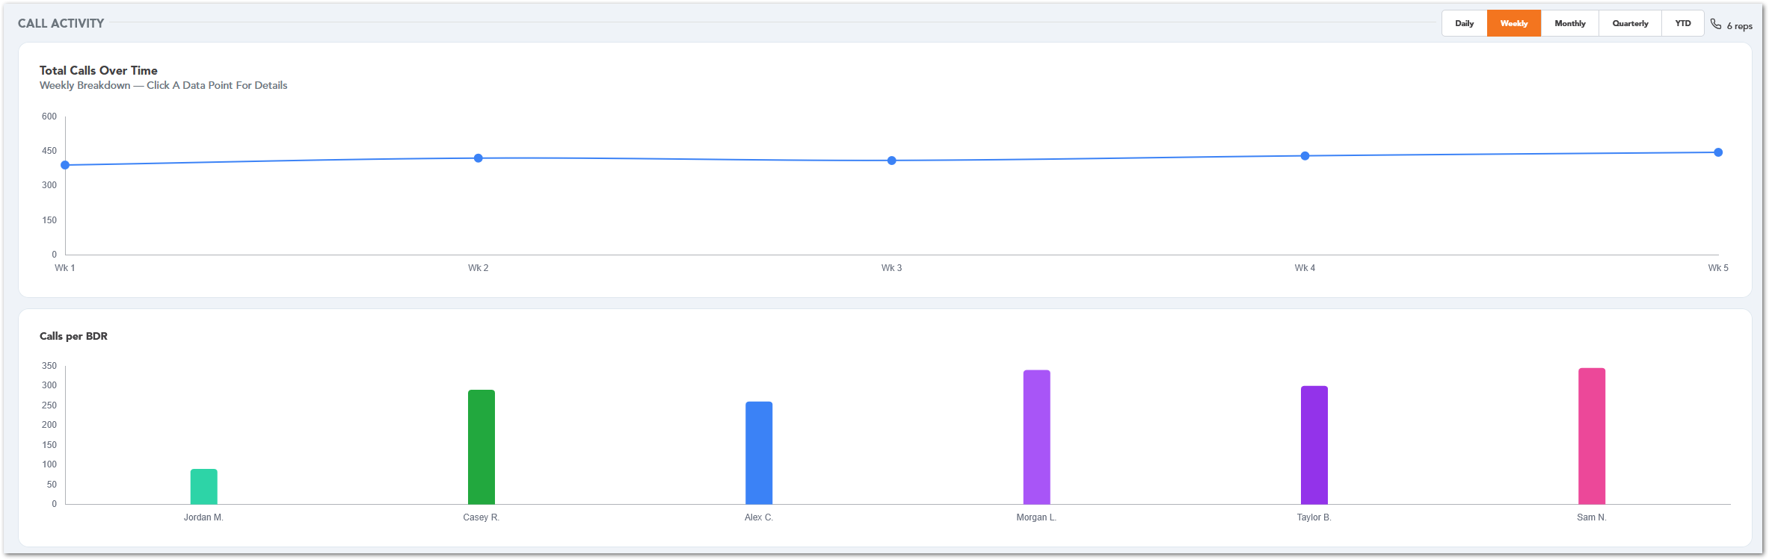

Sales Performance
The Sales Performance section shows team sales activity by BDR. It includes a Business vs Personal Sales chart and a Sales Trend chart, helping supervisors compare sales distribution across BDRs and review how business and personal sales change over time.
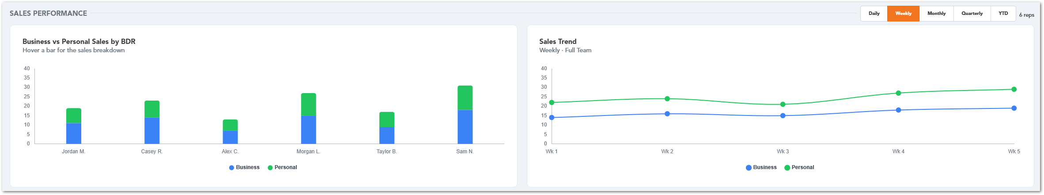

Revenue Performance
The Revenue Performance section summarizes revenue generated by each BDR and shows the team revenue trend for the selected timeframe. The revenue chart also includes an average reference line, helping supervisors compare individual revenue results against the team average.
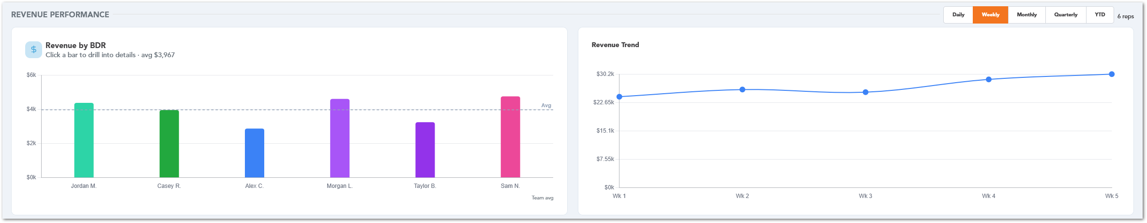

Revenue by BDR Drill-Down
When users select a bar in the Revenue by BDR chart, CUBE opens an invoice detail table for the selected BDR and timeframe. The table displays the invoices included in that BDR’s revenue total, including the date created, MySQL invoice number, customer number, customer name, invoice status, invoice total, and related site information. This allows supervisors to review the invoice records behind the revenue value instead of only seeing the chart total.
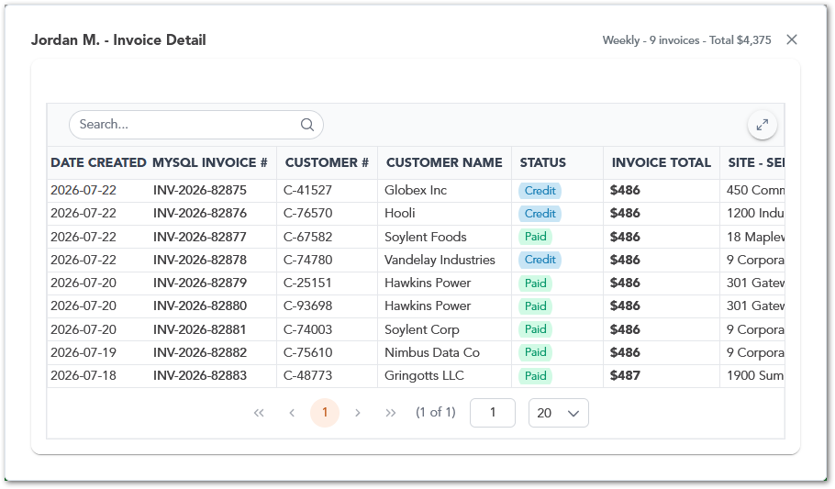

Payout Tracking
The Payout Tracking section summarizes estimated payout information based on converted sales. It includes total estimated payout, business sales, personal sales, estimated payout by BDR, and a payout breakdown table. This helps supervisors review payout estimates, compare BDR earnings, and understand how business and personal sales contribute to the total estimated payout.
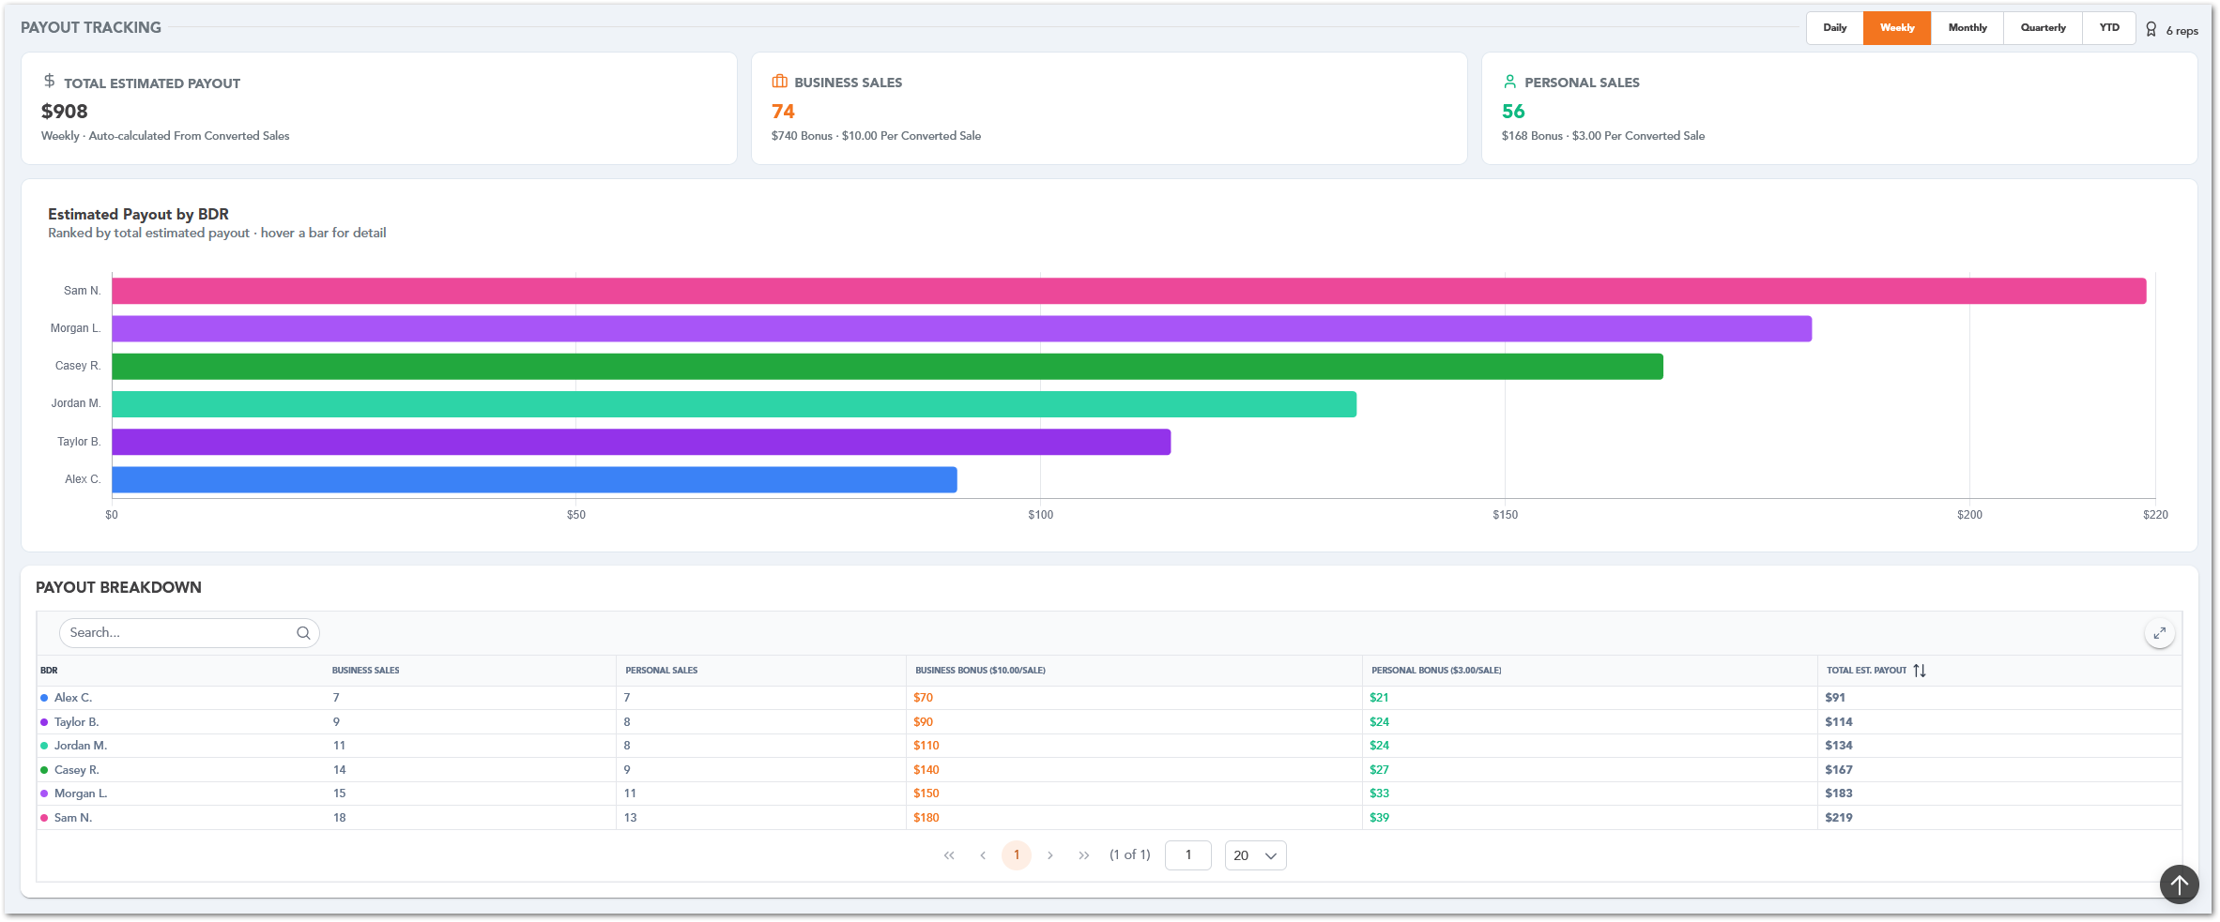

CSM Dashboard
The CSM Dashboard provides Client Success Managers with a portfolio-level view of customer growth, retention, revenue activity, and quote performance. This dashboard helps users monitor portfolio revenue, review customer activity, identify conversion results, and understand where quote value is being won or lost.
The dashboard includes filters for reviewing information by date range and customer group. These filters update the displayed KPIs, charts, and customer activity information based on the selected criteria.

KPI Summary
The KPI Summary section displays the main portfolio indicators for the selected period. It includes portfolio revenue, revenue growth, active customers, total sites, and average revenue per customer. These cards provide a quick overview of portfolio performance and help users evaluate customer growth and revenue health.
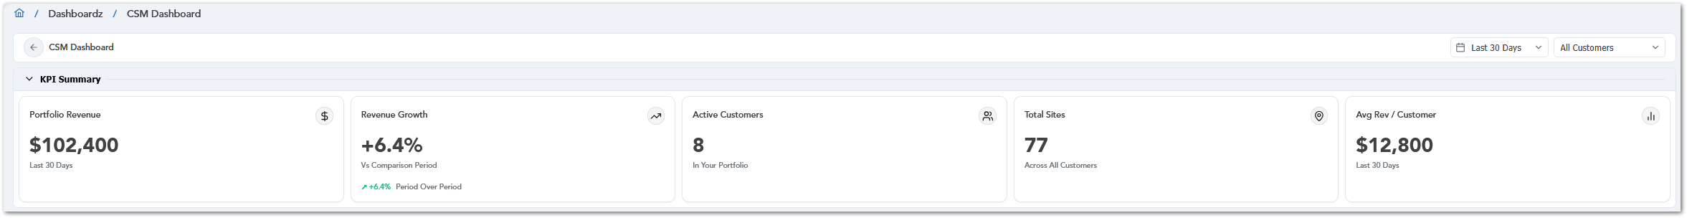

Dashboard Filters
The CSM Dashboard includes filters for selecting the date range and customer scope. Users can choose predefined date ranges such as Last 7 Days, Last 30 Days, Last 90 Days, and Year to Date, or use a custom range when available. Users can also filter the dashboard by All Customers or select a specific customer from the list. When a filter is applied, the KPI Summary and Customer Activity sections update based on the selected date range and customer selection.
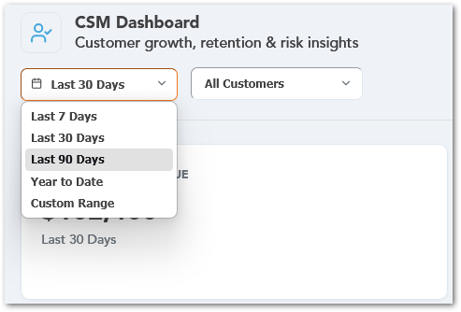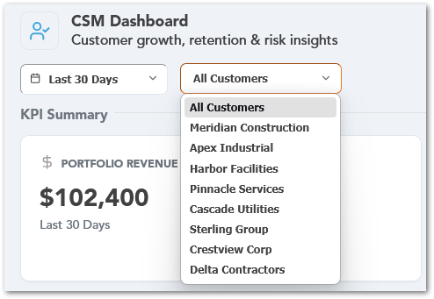

Customer Activity
The Customer Activity section summarizes quote activity for the selected period. It includes total quotes, quotes won, quotes lost, and conversion percentage. The section also provides charts for total quotes by customer and lost value by reason, helping users identify quote volume, conversion performance, and the main reasons for lost value.
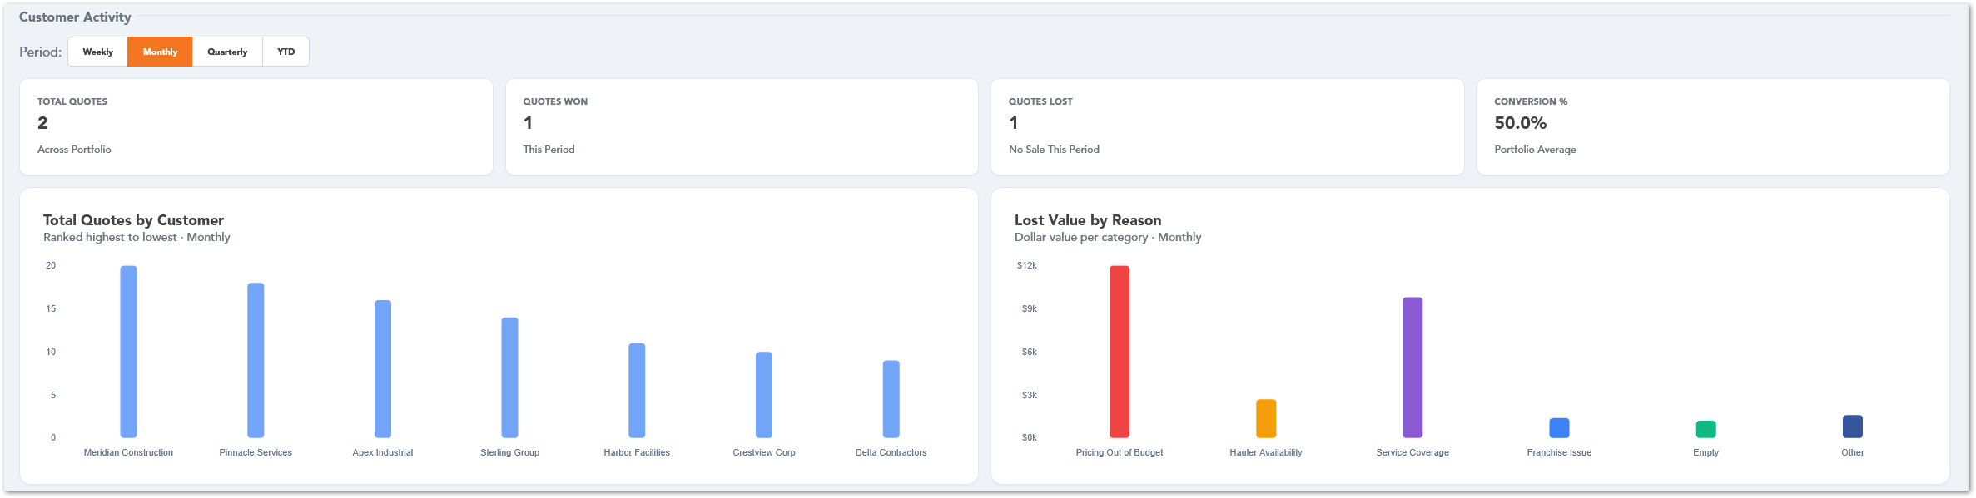
The Quote Breakdown by Customer table provides a detailed customer-level view of quote activity. It displays total quotes, won quotes, lost quotes, and conversion percentage for each customer, allowing users to compare customer performance and identify accounts that may require follow-up.
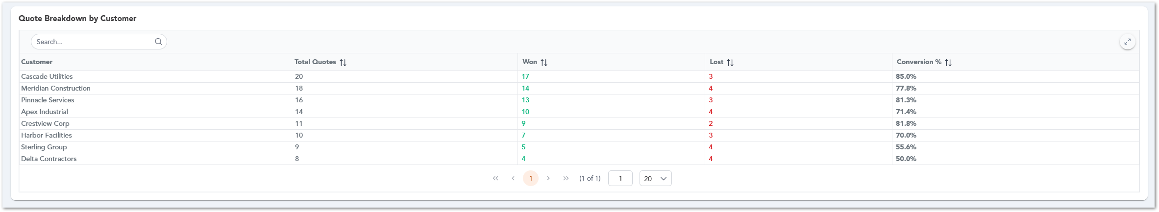

PSP Specialist
The PSP Specialist dashboard provides a consolidated view of provider-related activity, performance, compliance, revenue, and ticket workload. This dashboard helps PSP Specialists monitor assigned providers, identify items that require attention, review documentation alerts, and track key operational indicators from a single landing page.

PSP Performance
The PSP Performance section displays win-versus-loss performance by product. Each product includes a circular win-rate chart and a count of wins and losses. This allows users to quickly compare performance across different product categories, such as Toilets, Roll-offs, Containers, and Fencing. Users can change the reporting period using the available filters, including Daily, Weekly, Monthly, Quarterly, and YTD.
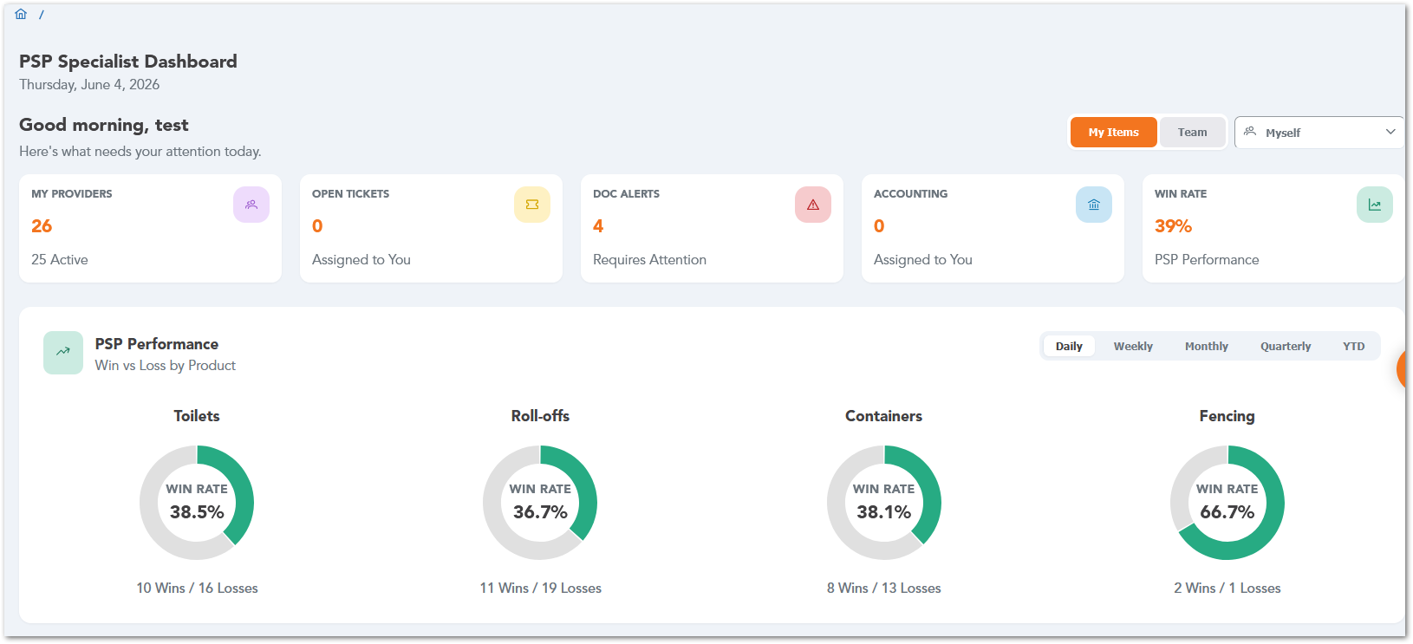

PSP Status Overview
The PSP Status Overview section summarizes provider verification and authorization status. It displays the total number of PSPs, how many are verified, how many are authorized, and how many are not authorized.
The section also includes progress bars for verification status and authorization status. These bars provide a quick visual summary of provider compliance, helping users identify whether provider records are complete and authorized for use.
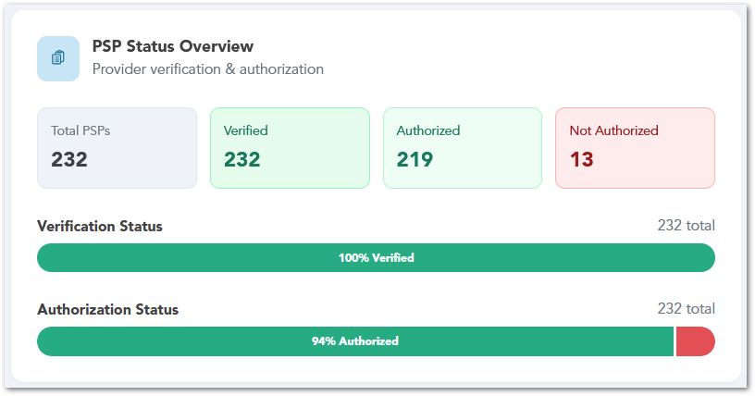

Accounting Inquiries
The Accounting Inquiries section shows the top Service Providers by inquiry volume. The bar chart helps users identify which Service Providers have the highest number of accounting-related inquiries.
This section is useful for reviewing Service Provider activity and identifying providers that may require additional accounting follow-up.
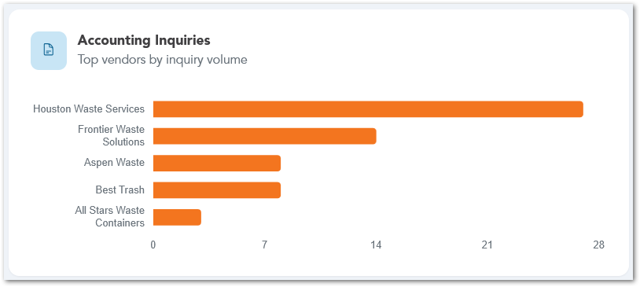

Inquiry Status Breakdown
The Inquiry Status Breakdown section displays accounting inquiries by status. Each status is represented in a horizontal bar chart, allowing users to compare the number of inquiries in each stage.
This section helps users understand where accounting inquiries are currently located in the workflow, such as new inquiries, items ready for approval, research items, lead approval items, or sales review items.
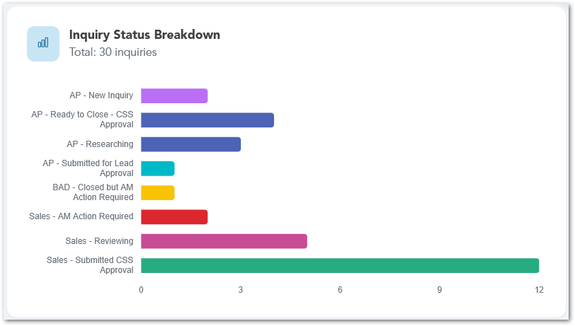

PSP Revenue
The PSP Revenue section provides a revenue overview for the selected period. Users can switch between Weekly, Monthly, Quarterly, and YTD views to review revenue performance over time.
This section displays the PSP contribution to revenue, the revenue amount for the selected period, and a revenue trend chart. It also lists the top providers by revenue, including the number of items and the revenue amount associated with each provider. The Details option allows users to access additional revenue information when available.
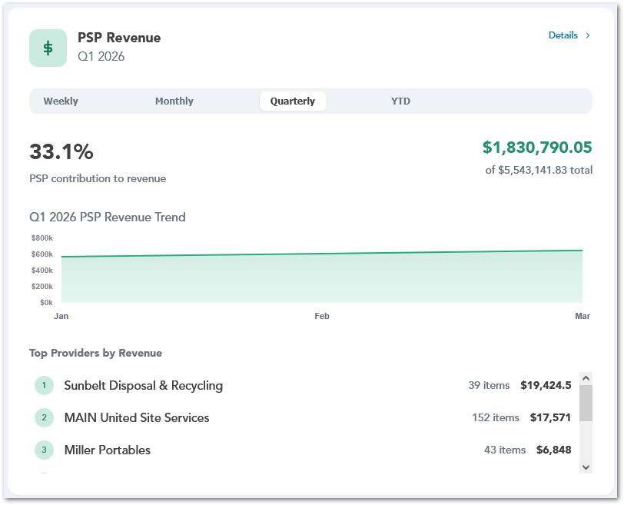

My Providers
The My Providers section displays the providers assigned to the current user. It shows a summary of active providers, providers with issues, and providers with document risk.
Each provider entry includes the provider name, current status, and recent activity information. Users can use this section to monitor their assigned providers and quickly identify providers that may require attention. The View All option allows users to open the complete provider list when additional review is needed.
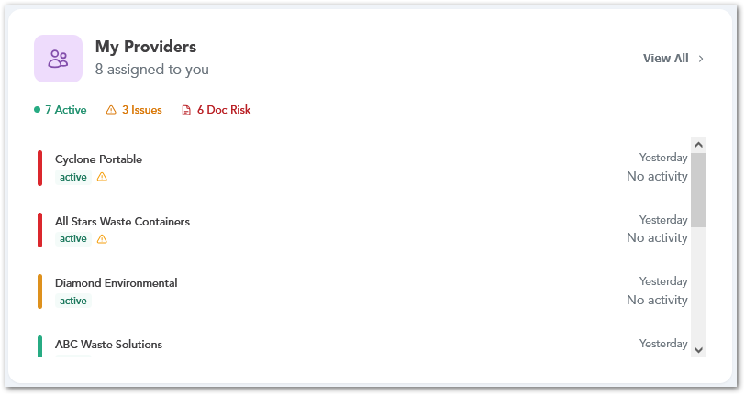

Documentation Alerts
The Documentation Alerts section displays COI and W9 compliance status for providers. It summarizes missing, expired, and expiring-soon documents.
Below the summary cards, the section lists providers requiring attention and identifies the specific documentation issue, such as an expired COI or missing W9. This helps users quickly prioritize providers that need doc follow-up. The View All option allows users to review the full list of documentation alerts.
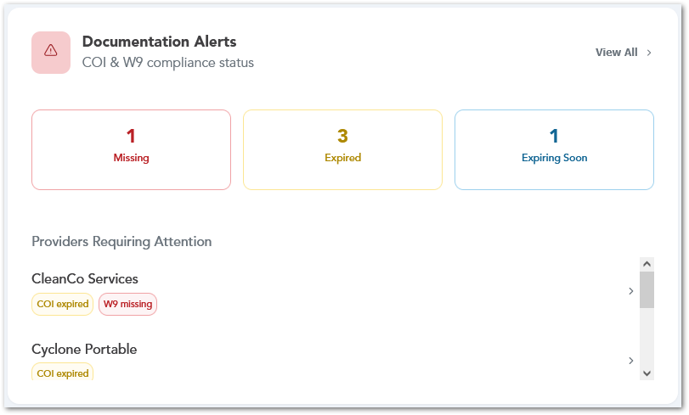

SPM Tickets
The SPM Tickets section provides an overview of the Service Provider management ticket queue. It displays the number of open tickets assigned to the current user and the total number of open tickets for the team.
The section also includes a status breakdown for tickets, such as pending, assigned, in progress, submitted for approval, and stalled. This helps users understand the current state of the SPM ticket queue and identify whether any tickets require follow-up. The View All option allows users to open the complete ticket list.
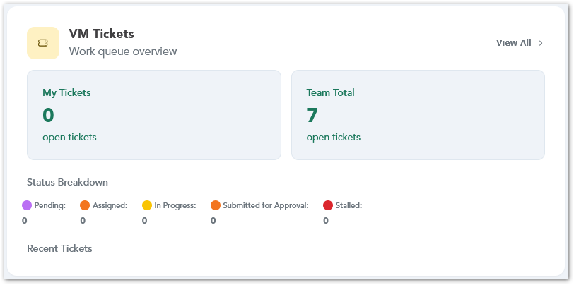

Service Provider Summary
The Service Provider Summary dashboard provides a high-level overview of service provider activity, lifecycle status, compliance risk, inquiry volume, revenue distribution, and PSP performance. This dashboard is intended to help users review provider-related metrics across the organization, identify areas that may require attention, and compare provider performance from a single summary page.

Service Provider Snapshot
The Service Provider Snapshot displays key totals related to service providers, including total service providers, total PSPs, authorized providers, verified providers, active providers, active compliance issues, active stock notices, and providers bought out. These summary cards provide a quick view of the current provider population and its overall status.
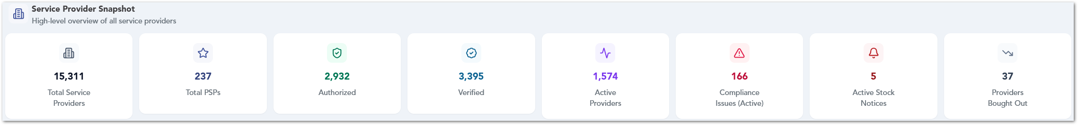

Provider Lifecycle Distribution
The Provider Lifecycle Distribution chart shows service providers grouped by lifecycle status, such as Draft, Pending Verification, Authorized, Verified, and DNU. This chart helps users understand how providers are distributed across different stages of the provider’s lifecycle.
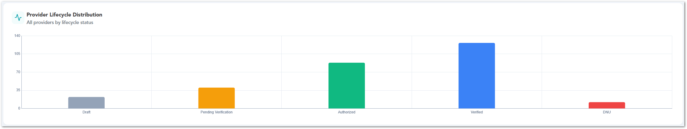

PSP by Specialist
The PSP by Specialist chart shows the number of providers assigned to each PSP Specialist. This helps users compare provider assignment volume across specialists and identify workload distribution.
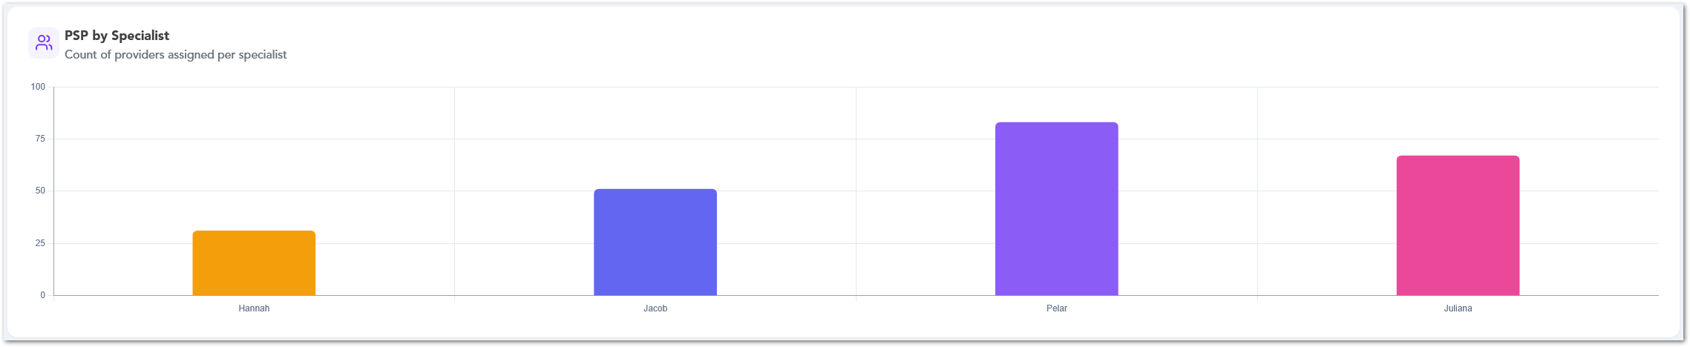

PSP Performance by Product
The PSP Performance by Product area displays win-versus-loss performance across product categories, such as Toilets, Roll-offs, Containers, and Fencing. Users can review win rate percentages and total wins and losses by product, with timeframe filters available for weekly, monthly, quarterly, and YTD views.
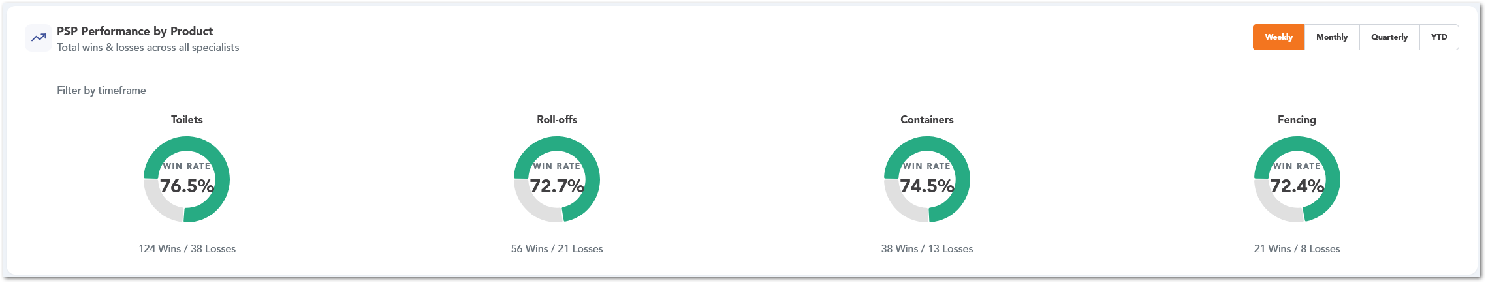

Compliance Risk
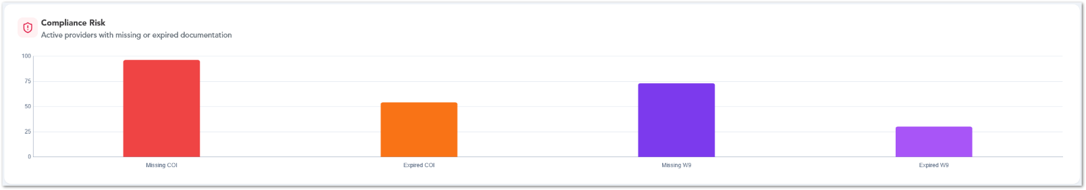
The Compliance Risk chart shows active providers with missing or expired documentation, such as missing COI, expired COI, missing W9, or expired W9. This section helps users identify documentation risks that may require follow-up.

Accounting Inquiries
The Accounting Inquiries section provides visibility into open accounting inquiry across service providers and specialists. It includes two charts: one showing the providers with the highest inquiry volume, and another showing how inquiries are distributed by workflow status. Together, these charts help users identify high-volume providers and understand where inquiries are currently positioned in the review or approval process.
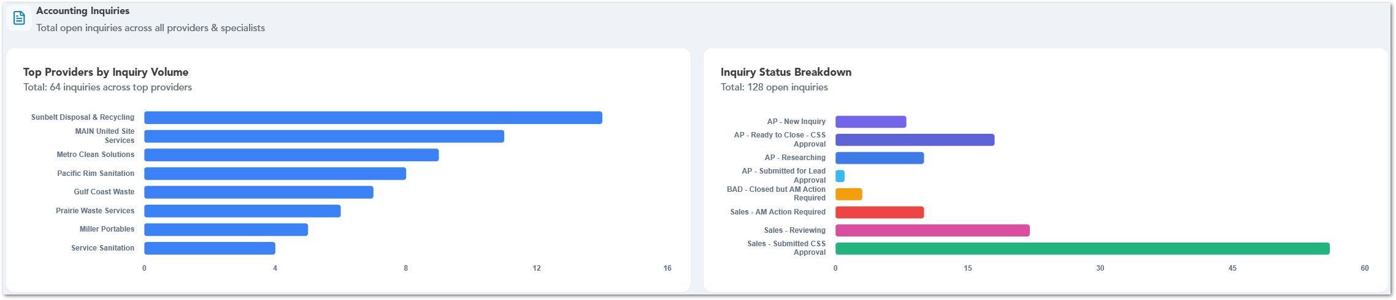

Revenue by Provider Type
The Revenue by Provider Type section compares PSP and non-PSP billed revenue. It displays year-to-date revenue totals, PSP revenue, non-PSP revenue, PSP revenue share, and monthly revenue distribution. This section helps users understand how PSP revenue contributes to overall billed revenue.
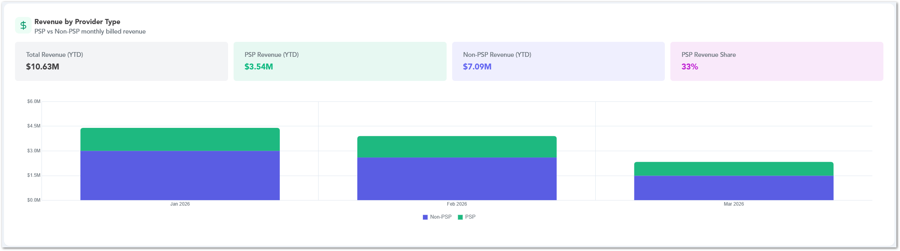

SPM Specialist Dashboard
The SPM Specialist dashboard provides a focused view of ticket workload, compliance risk, provider lifecycle status, and operational readiness. This dashboard helps SPM Specialists monitor open and aging tickets, identify critical documentation issues, review COI upload activity, and track provider readiness indicators from a single page.

Ticket Summary
The Ticket Summary cards provide a quick overview of the current ticket workload. Users can review the number of open tickets, critical tickets, tickets older than seven days, and tickets older than thirty days. These cards help users quickly identify workload volume and aging items that may require follow-up.

Ticket Aging Buckets
The Ticket Aging Buckets chart groups tickets by age range, such as 0-7 days, 8-14 days, 15-30 days, and 30+ days. This chart helps users understand how long tickets have been open and identify older tickets that may need attention.
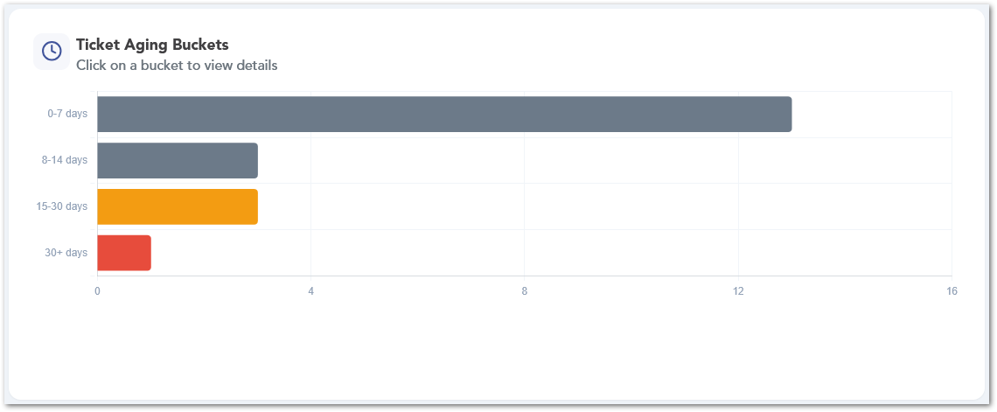

Average Resolution Time
The Average Resolution Time chart shows ticket resolution performance by ticket category. This allows users to compare how long different types of tickets typically take to resolve and identify categories that may require process review.
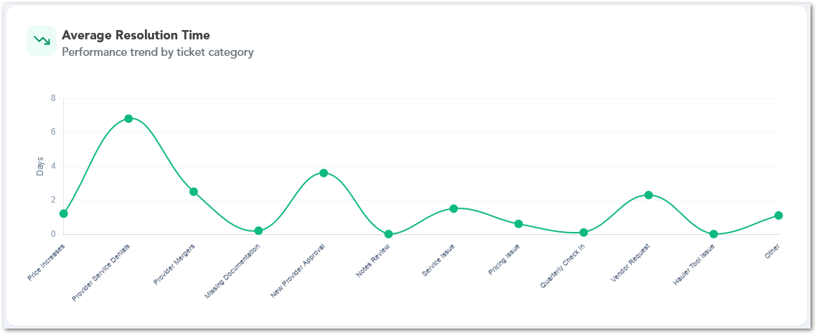

Compliance Risk
The Compliance Risk section displays provider documentation issues, including missing COI, expired COI, missing W9, expired W9, and COI documents expiring within 30 days. This section helps users prioritize documentation follow-up and reduce compliance risk.

COI Expiration Timeline
The COI Expiration Timeline chart shows upcoming COI expirations by month. Users can select a month to review providers with expiring documentation and plan follow-up before documents become expired.
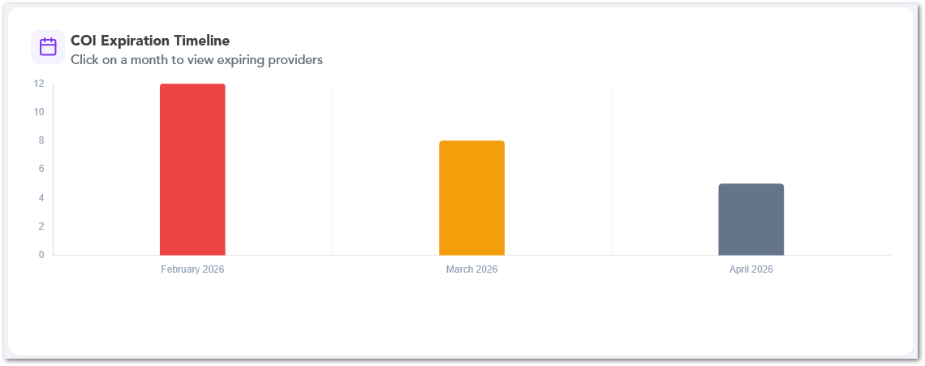

COI Upload Activity
The COI Upload Activity chart shows COI uploads by team members across the selected timeframe. Users can switch between Today, Weekly, Monthly, Quarterly, and YTD views to review upload activity and compare team contribution.
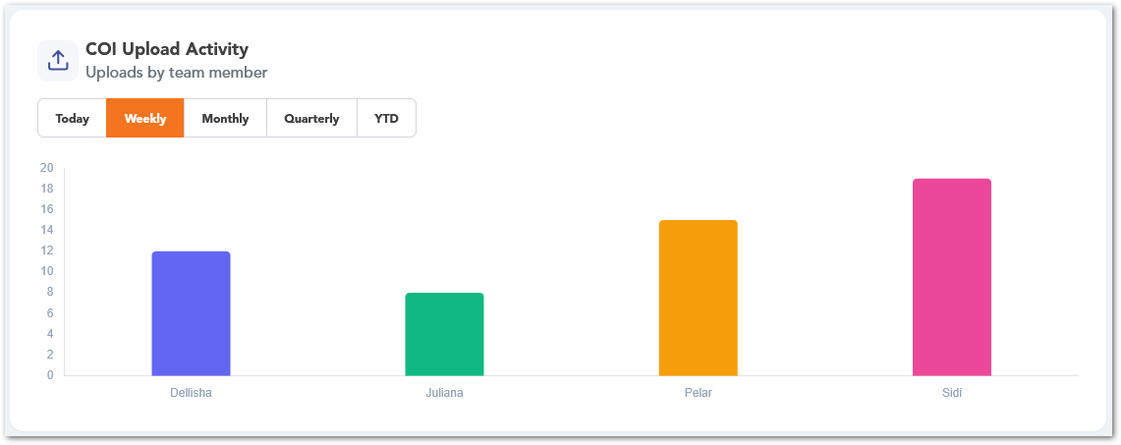

Provider Lifecycle Distribution
The Provider Lifecycle Distribution chart shows providers grouped by lifecycle status, such as Draft, Pending Verification, Authorized, Verified, and DNU. This helps users understand how providers are distributed across key lifecycle stages.
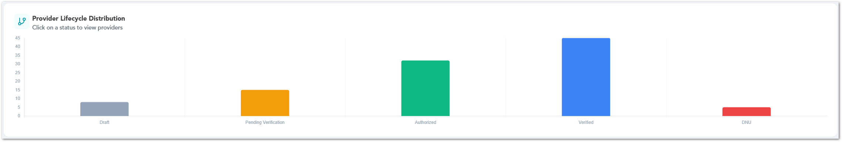

Operational Readiness
The Operational Readiness section highlights provider records that may require operational follow-up, such as providers with active stock notices, missing operating hours, incomplete contact data, or providers bought out. These cards help users identify readiness gaps that may affect provider usage or service coordination.

Service Provider Team Lead Dashboard
The Service Provider Team Lead dashboard provides team-level visibility into PSP assignments, approvals, sales performance, accounting inquiries, documentation gaps, and event-related follow-up work. This dashboard helps team leads monitor specialist workload, compare performance across team members, and identify provider-related items that require coordination or outreach.

Team Members
The Team Members section displays the members included in the team view, along with their names and roles. This provides context for the dashboard metrics and helps users understand which team members are represented in the performance and workload sections.
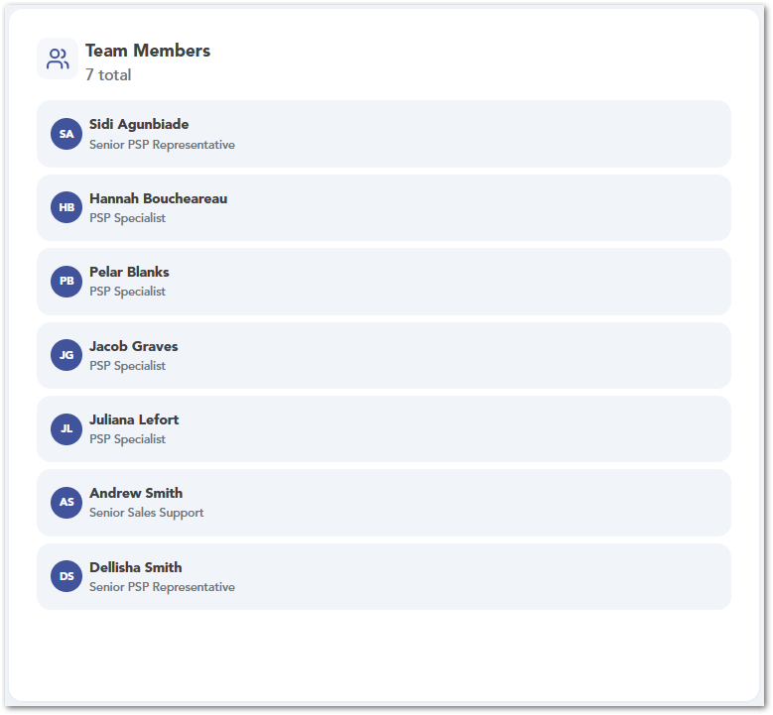

PSP Specialists Overview
The PSP Specialist Overview section summarizes provider assignments and verification status by specialists. It shows each specialist’s total PSP count, verified providers, and authorized providers, allowing team leads to compare workload and provider readiness across the team.
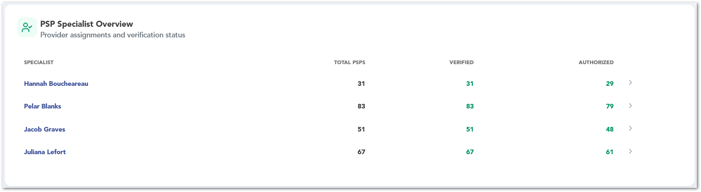

Approved PSPs and Monthly Approvals
The Approved PSPs card displays the year-to-date number of approved PSPs. The Monthly Approvals chart shows approval activity by month, helping team leads monitor approval trends over time.
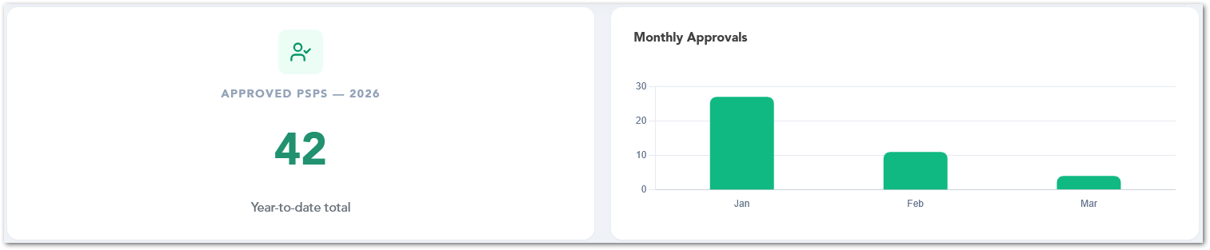

PSP Sales Win Rate Summary
The PSP Sales Win Rate Summary compare win rate percentages by product type and specialist. Users can review performance across product categories such as Toilets, Roll-offs, Containers, and Fencing, and switch between Weekly, Monthly, Quarterly, and YTD views.
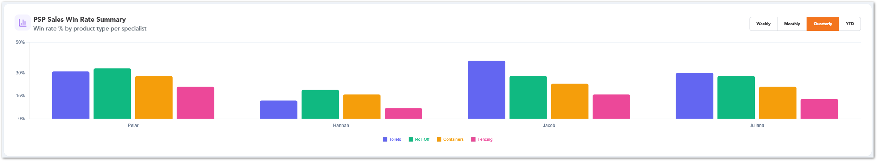

Open Accounting Inquiries by PSP Specialist
The Open Accounting Inquiries by PSP Specialist chart shows the current number of open accounting inquiries assigned to each specialist. This helps team leads identify inquiry workload distribution and determine where follow-up or support may be needed.
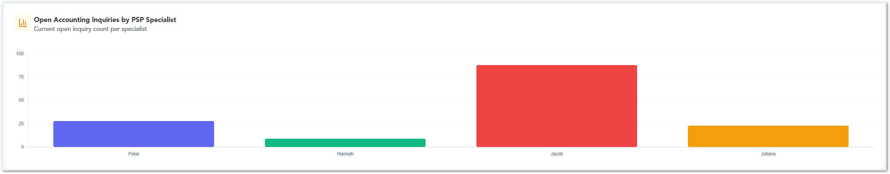

Compliance / Documentation
The Compliance / Documentation section highlights providers with missing documentation that may require outreach. It includes a total count of active providers missing documentation and a provider type breakdown, helping team leads identify documentation risk by provider category.
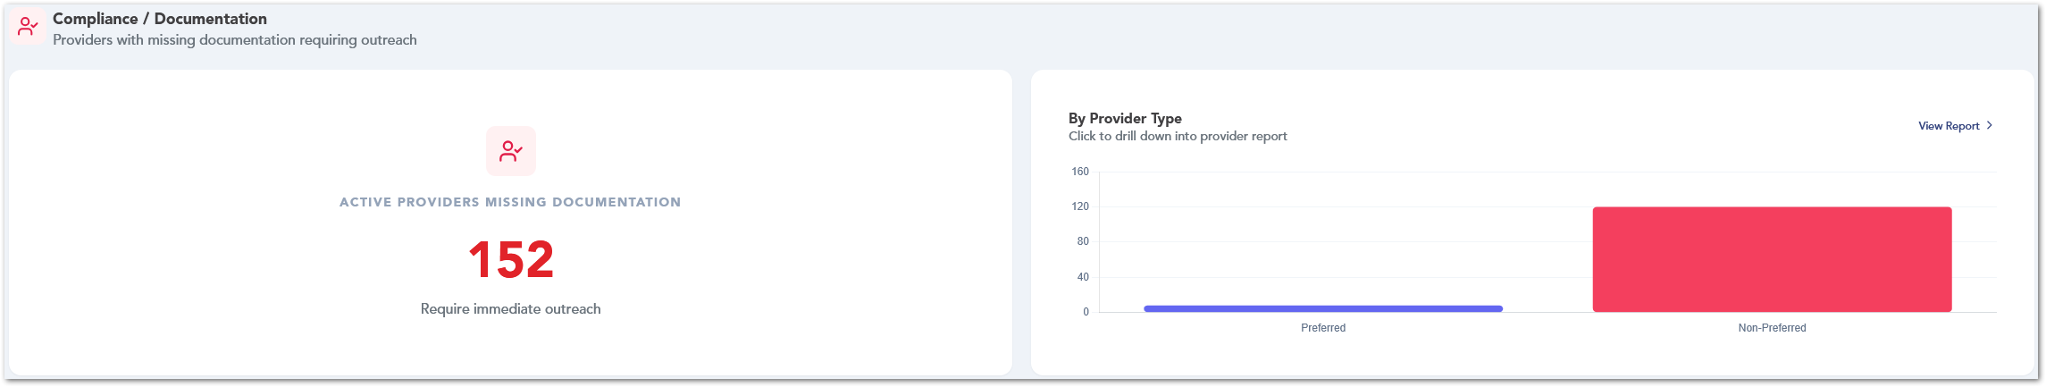

Event Toilet Confirmation
The Event Toilet Confirmation section provides visibility into event-related confirmation requests for the current week. It includes a status overview chart and a follow-up list showing requests that require action, including Service Provider, customer, delivery date, quantity, and current status.
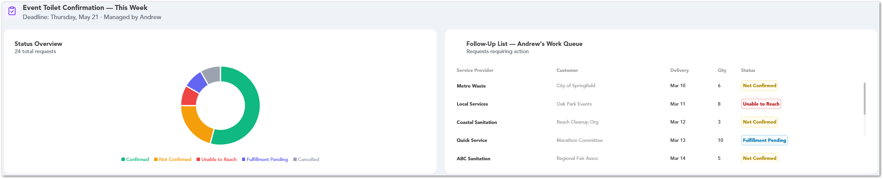

Tonnage
The Tonnage dashboard provides visibility into the event toilet confirmations and final tonnage tracking. This dashboard helps users monitor confirmation progress, identify remaining event toilet follow-ups, review missing final tonnage items, and track who entered final tonnage information.

Event Toilet Confirmation
The Event Toilet Confirmation section summarizes toilet confirmation activity for the current week. It displays key totals such as event toilets this week, unique providers to contact, confirmed items, and remaining confirmations. This section helps users understand the current confirmation workload and track progress toward completion.

Confirmation Progress
The Confirmation Progress section shows the percentage of completed confirmations against the total confirmation requirement. It separates confirmed and remaining items so users can quickly identify how much work has been completed and how much still requires follow-up.
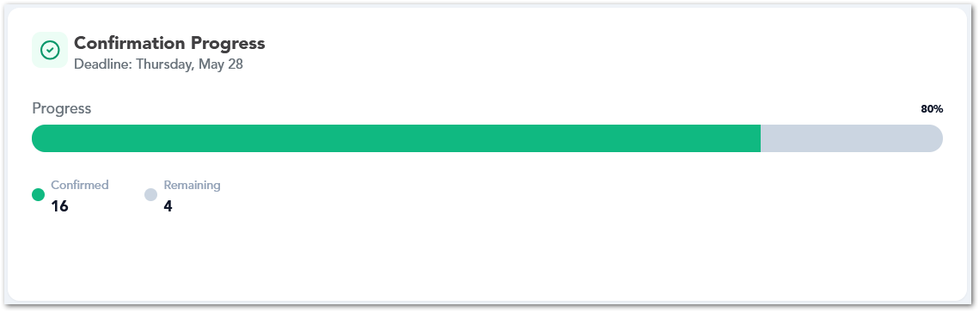

Status Breakdown
The Status Breakdown chart displays event toilet confirmations by status, such as Confirmed, Not Confirmed, Unable to Reach, Fulfillment Pending, or Cancelled. This helps users understand the current state of event confirmations and identify where follow-up may be required.
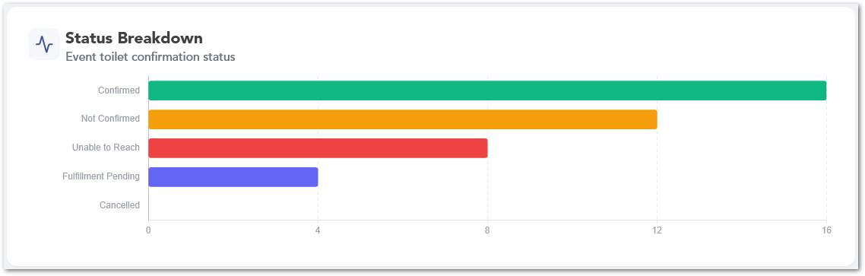

Tonnage Overview
The Tonnage Overview section provides a summary of final tonnage completion. It highlights the number of completed services still waiting for final tonnage, the overall completion rate, and any backlog indicators. Users can also access related actions, such as opening Rossum or Invoices, when available.
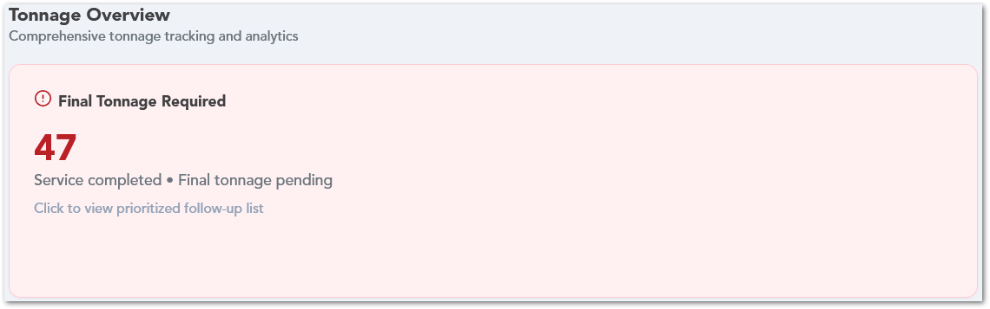

Completion Rate
The Completion Rate card shows the percentage of tickets that already have final tonnage entered. It also displays the number of completed tickets against the total ticket count and may show a trend indicator or warning message when the completion rate is dropping or a backlog is forming.
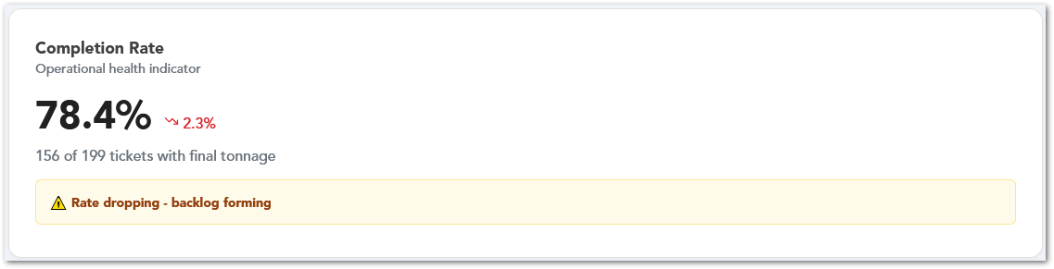

Missing Tonnage - Aging Buckets
The Missing Tonnage - Aging Buckets chart groups missing final tonnage items by age based on the service end date. This helps users prioritize older pending items and identify whether the missing tonnage backlog is increasing.
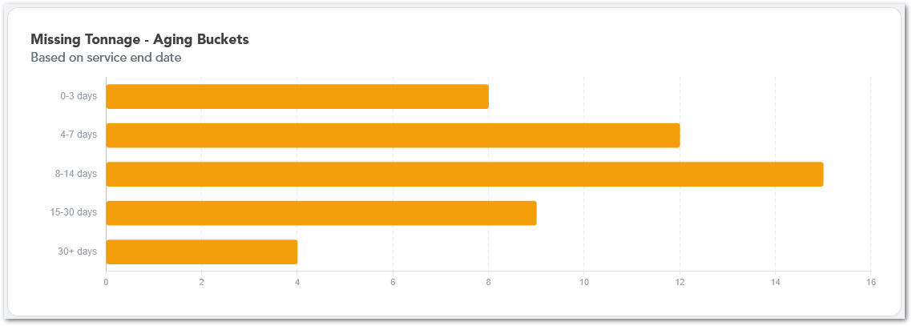

Top Providers Missing Tonnage
The Top Providers Missing Tonnage chart shows which providers have the highest number of missing final tonnage items. This view helps users prioritize follow-up by provider.
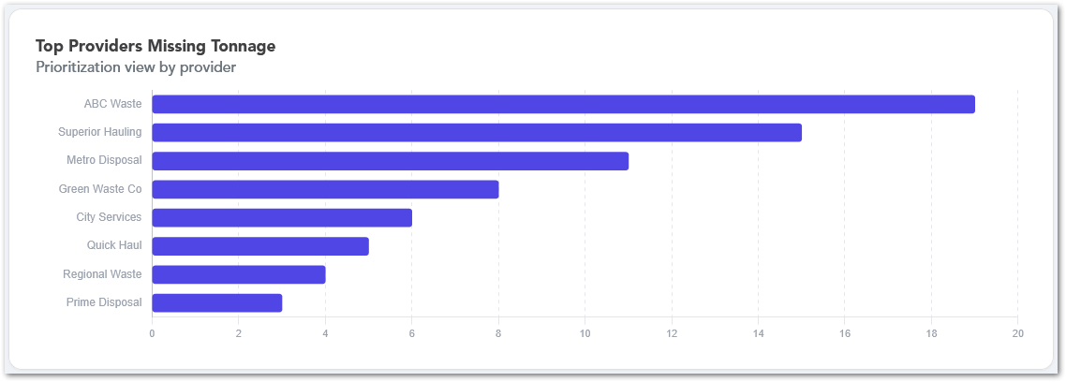

Tonnage Inputted By
The Tonnage Inputted By chart shows who entered final tonnage and when. Users can switch between timeframes, such as Today, This Week, This Month, This Quarter, and YTD, to review tonnage entry activity by user or source.
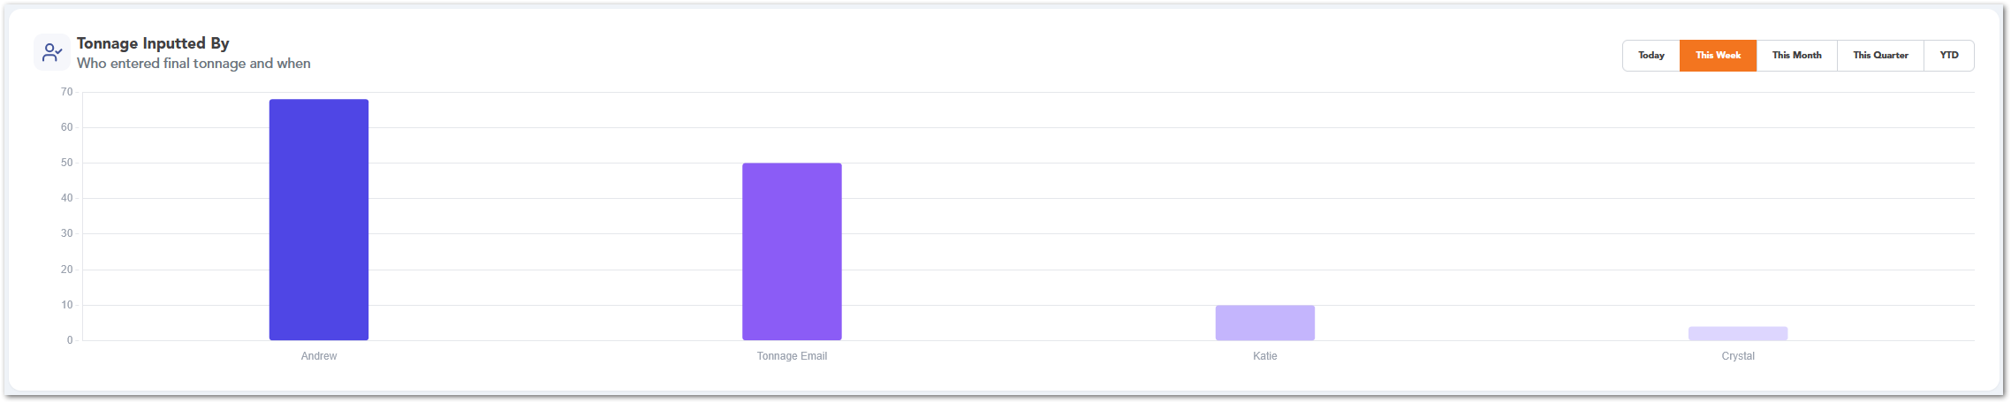

REPORTZ SECTION
The Reportz section provides access to data analysis and reporting tools within the platform. It includes predefined, custom, and AI-generated reports, as well as integrations with Power BI dashboards. Users can analyze operational and financial data to support decision-making. This section enables visibility into system performance and business insights.

Documentation Compliance
The Documentation Compliance page provides a compliance-focused view of Service Provider documentation, specifically for COI and W9 tracking. The page helps users identify providers with missing, expired, or soon-to-expire documentation so they can prioritize follow-up and keep provider records up to date.
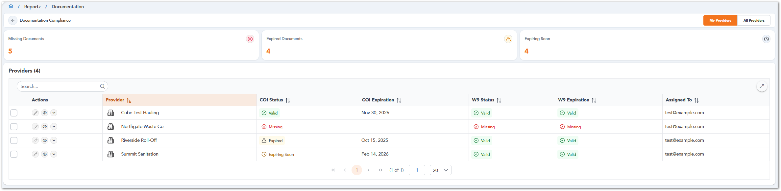
At the top of the page, users can review summary cards for Missing Documents, Expired Documents, and Expiring Soon. Selecting any of these cards filters the provider table below based on the selected documentation status. Users can also switch between My Providers and All Providers to review only the providers assigned to them or all providers available in the report.
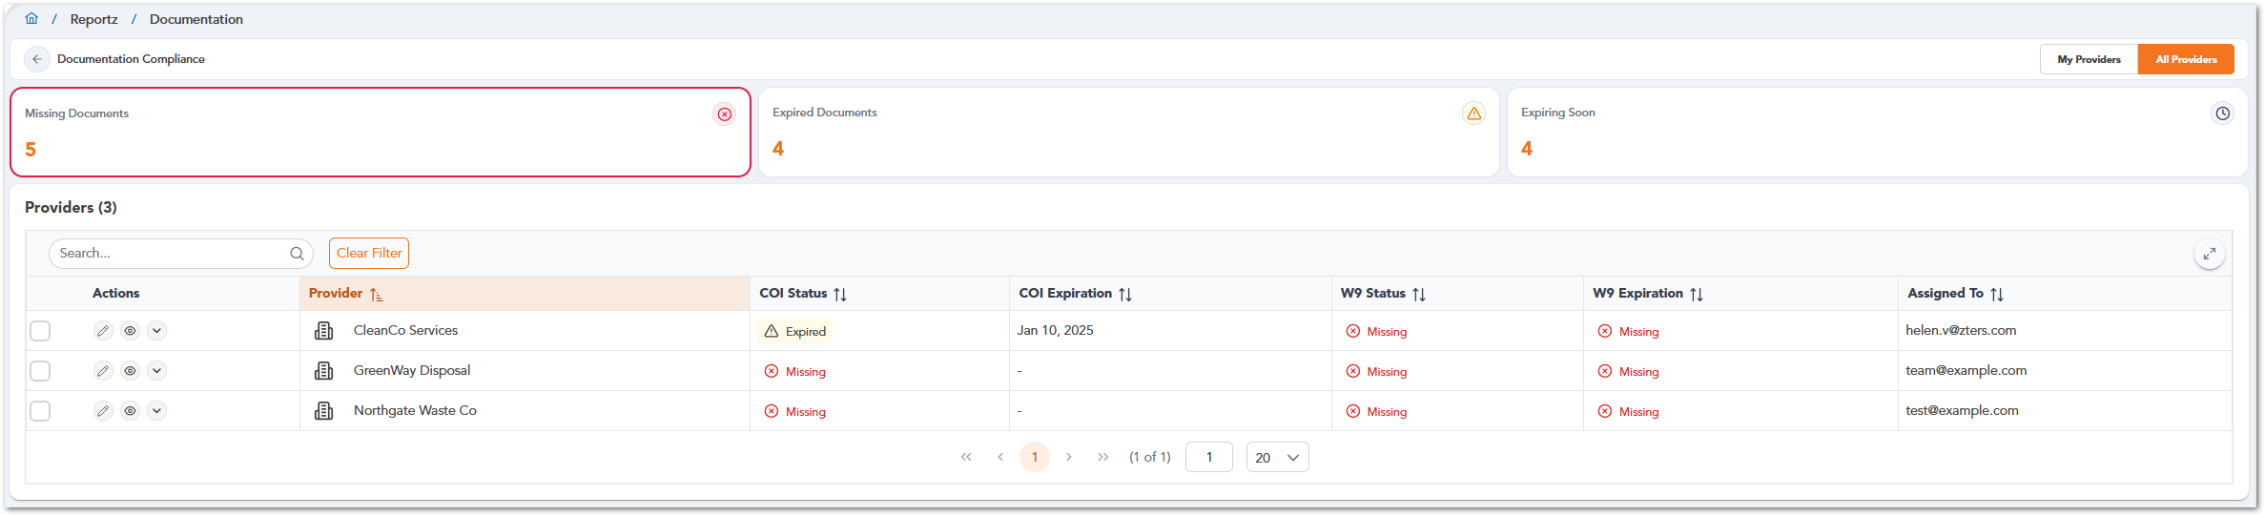
The Providers table displays the filtered provider list with key documentation details, including the provider name, COI status, COI expiration date, W9 status, W9 expiration, and assigned user. Status indicators help users quickly identify valid, missing, expired, or expiring documentation. The table also includes search, sorting, pagination, and row-level actions so users can locate and review provider records more efficiently.
The following fields explain the provider documentation tracked in this report:
Field | Description
COI Status | Shows the current status of the provider’s Certificate of Insurance (COI). A COI is a document that confirms the provider has insurance coverage on file. The status may show whether the COI is valid, missing, expired, or expiring soon.
COI Expiration | Shows the expiration date of the provider’s Certificate of Insurance. This helps users know when the insurance document needs to be renewed or followed up on.
W9 Status | Shows the current status of the provider’s W9 form. A W9 is a tax form used to collect the provider’s taxpayer information for reporting and payment purposes. The status may show whether the W9 is valid, missing, expired, or requires attention.
W9 Expiration | Shows the expiration status or expiration date associated with the provider’s W9 documentation, when applicable. If the W9 is missing, the field may display a missing status instead of a date.

The Actions column provides row-level options for each provider. Users can select the pencil icon to open the related Service Provider record in edit mode, select the eye icon to view the provider record, or use the expand option to display additional documentation compliance details for that provider. When users open a provider with missing or expired documentation, the Service Provider page may display a Fix option so users can address the documentation issue from the provider record.

PSP Coverage Map
The PSP Coverage Map provides a geographic view of Premier Service Providers across the service area. Provider locations are displayed as colored map points, allowing users to visually review where PSPs are located and how provider coverage is distributed nationwide.
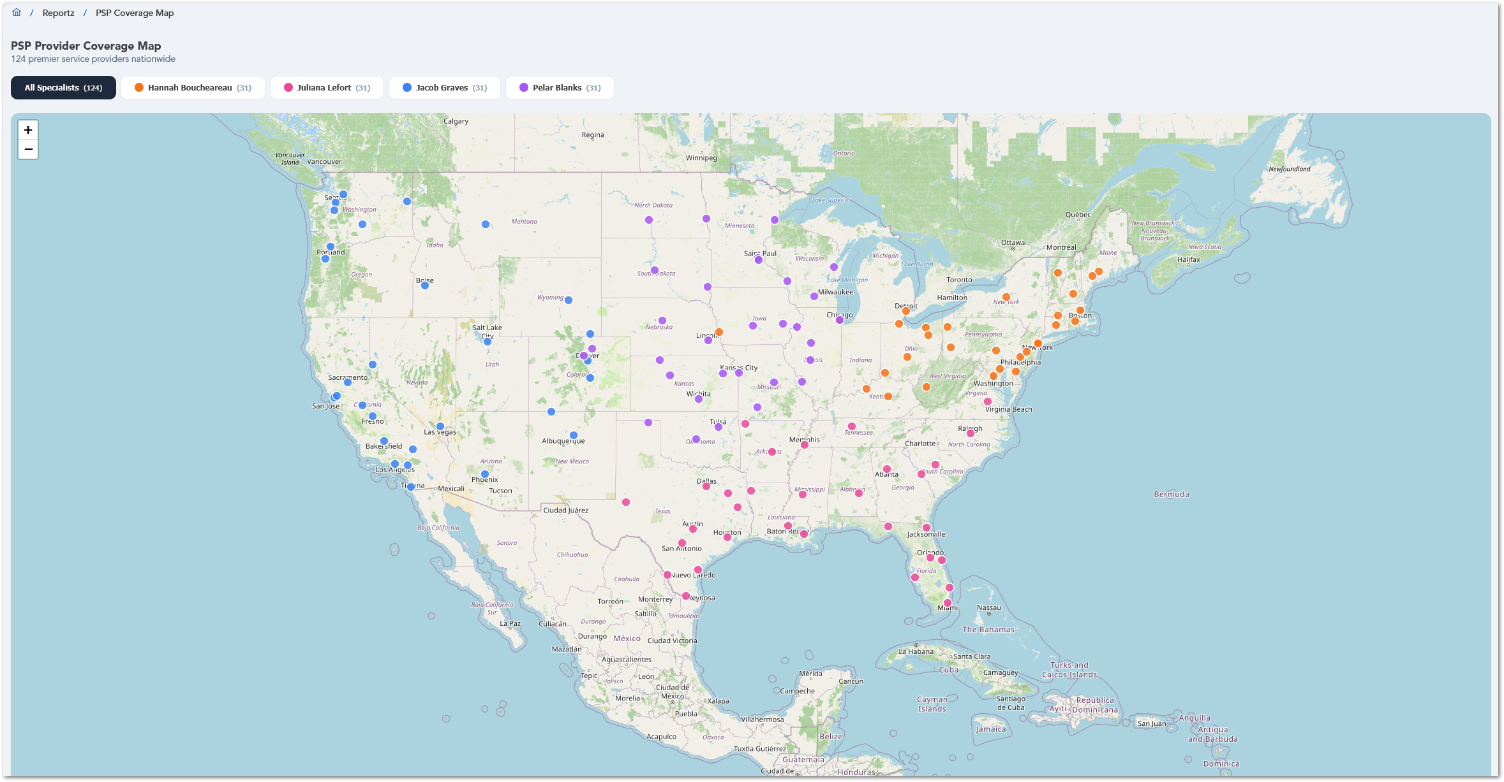

Users can filter the map by selecting All Specialists or an individual specialist from the options at the top of the page. When a specialist is selected, the map updates to show only the PSPs assigned to that specialist. This helps users quickly focus on the provider coverage for a specific specialist without reviewing the full national provider list.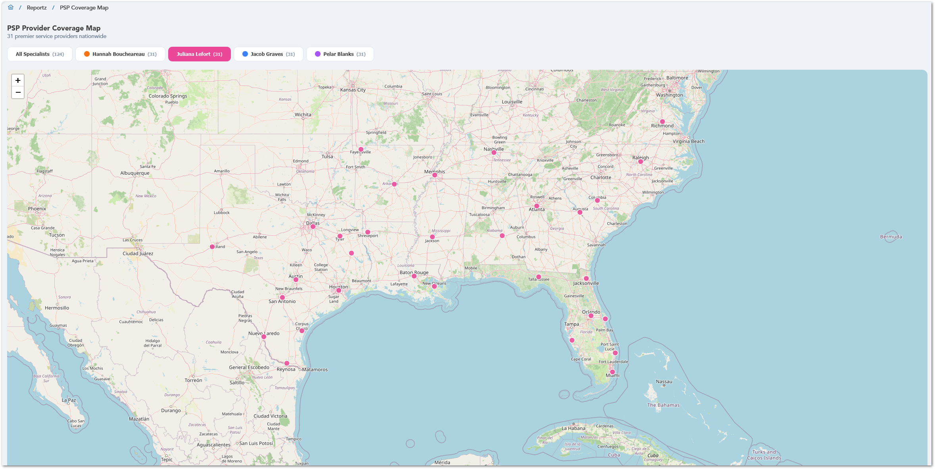
Each map point represents a Service Provider location. When users hover over a point, CUBE displays the Service Provider name and the assigned specialist. This makes it easier to identify a provider directly from the map while keeping the view simple and focused on coverage visibility.
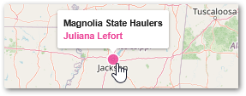

Static Reports
This module provides access to predefined reports with standard system metrics. It allows users to view consistent and ready-to-use data. It supports routine monitoring and analysis.
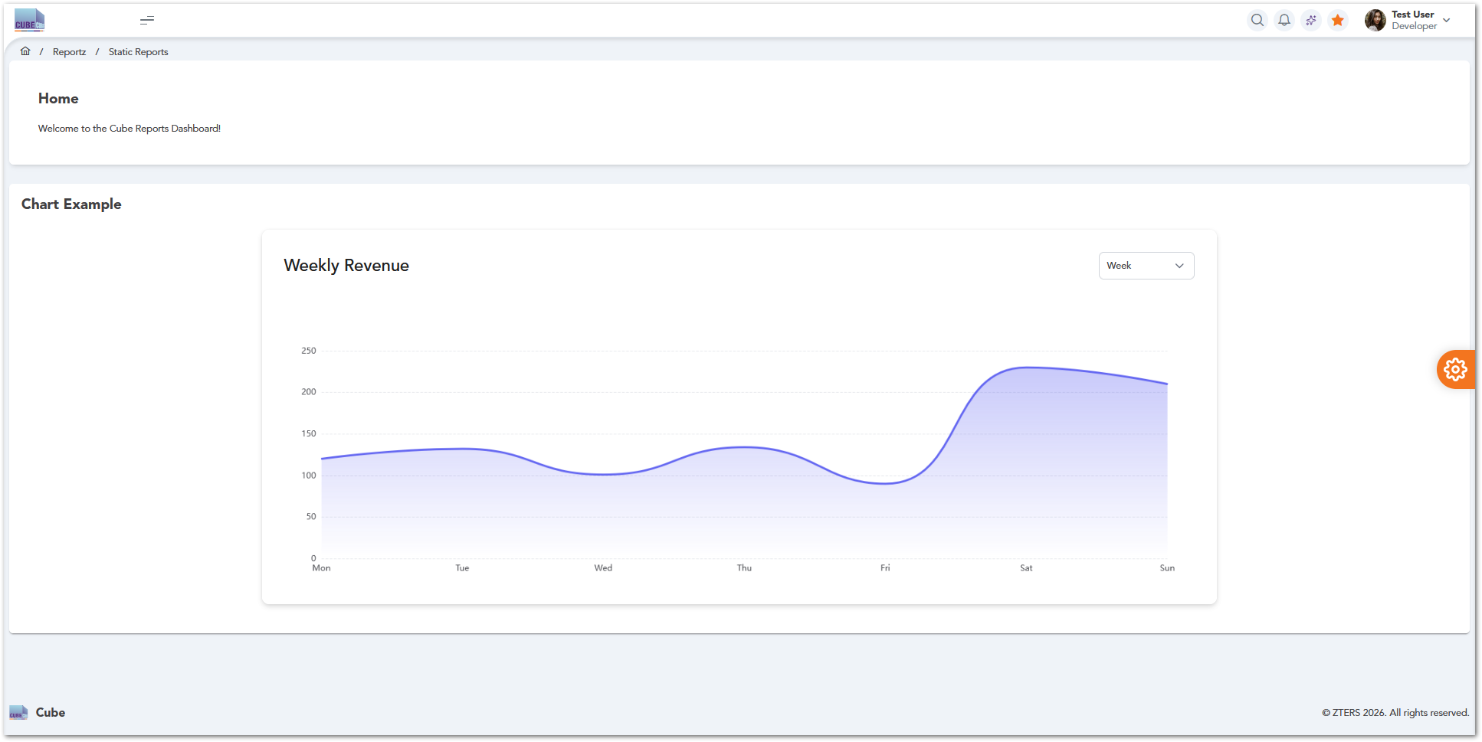

Custom Reports
This module allows users to create reports based on selected data fields and filters. It provides flexibility to generate tailored insights. It supports specific business and operational needs.
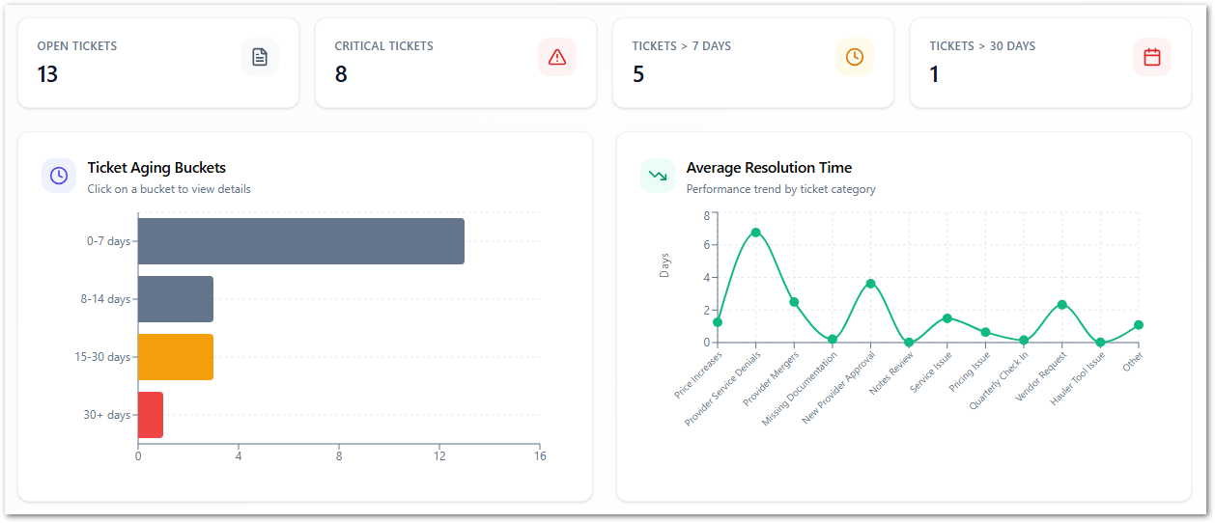

AI Reports
This module generates insights using AI-based analysis of system data. It helps identify trends, patterns, and potential predictions. It supports advanced decision-making.

Power BI Reports
This module provides access to reports integrated with Microsoft Power BI dashboards. It enables advanced data visualization and analytics. It supports business intelligence reporting.

OVERALL SYSTEM FUNCTIONALITIES
This section describes common functionalities available across multiple modules within the CUBE platform, such as data filtering, bulk actions, export options, and table interactions. These features provide users with efficient ways to manage and analyze data regardless of the module being used.

Bulk Actions
Users can select multiple service provider records and apply actions to them simultaneously. Steps to Perform Bulk Actions:
- Navigate to Operationz → Service Providers.
- Locate the list of service providers displayed in the table.
- Use the checkboxes in the Actions column to select one or more records.
- To select all records on the page, use the checkbox located in the table header.
- Once records are selected, available bulk actions can be applied (depending on system configuration).
- Confirm the action if prompted.
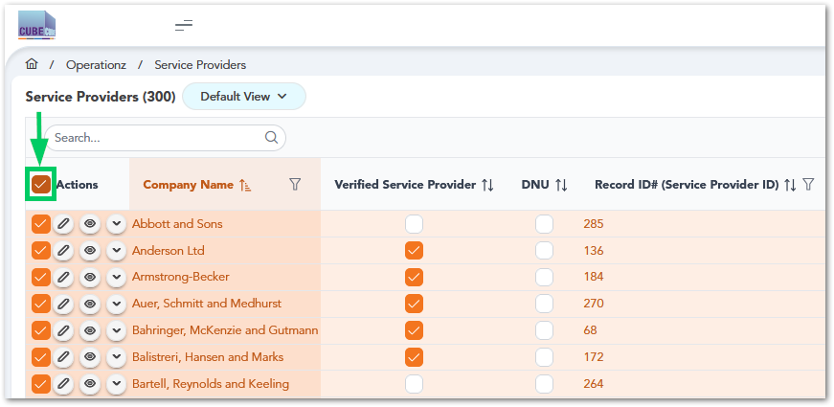

Export and Print Options
Users can export or print service provider data using the options available in the interface:
- Navigate to Operationz → Service Providers.
- Click the three-dot menu (⋯) located in the upper-right corner of the table.
- Select one of the following options:
- View Summary
- Export CSV
- Print
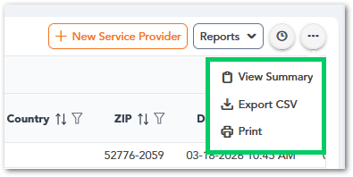

Filtering and Ordering
Ordering (Sort Data)
- Locate the column header (e.g., First Name, Last Name).
- Click the sorting icon (↑↓) next to the column name.
- Click once to sort in ascending order.
- Click again to switch to descending order.
Filtering (Narrow Results)
- Click the filter icon (funnel) next to the column name.
- Enter or select the desired filter criteria.
- Apply the filter to update the table results.
- Clear or reset the filter to return to the full dataset.


Search Bar
- Locate the search bar at the top of the data table.
- Enter a keyword related to the record you want to find (e.g., name, email, ID).
- The system will automatically filter results based on the entered text.
- Modify or clear the search input to update or reset the results.


Table Views
Users can customize how information is displayed in CUBE tables using the Active View dropdown:
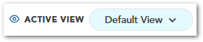
- Click Active View and select an existing Personal or Company View.
- Click the Edit (pencil) icon to modify the selected view.
- Under Columns, add, remove, or reorder the visible table columns.
- Under Filters and Sorting & Grouping, configure the information displayed and its order.
- Click Save View to save the configuration or View Without Saving to apply it temporarily.
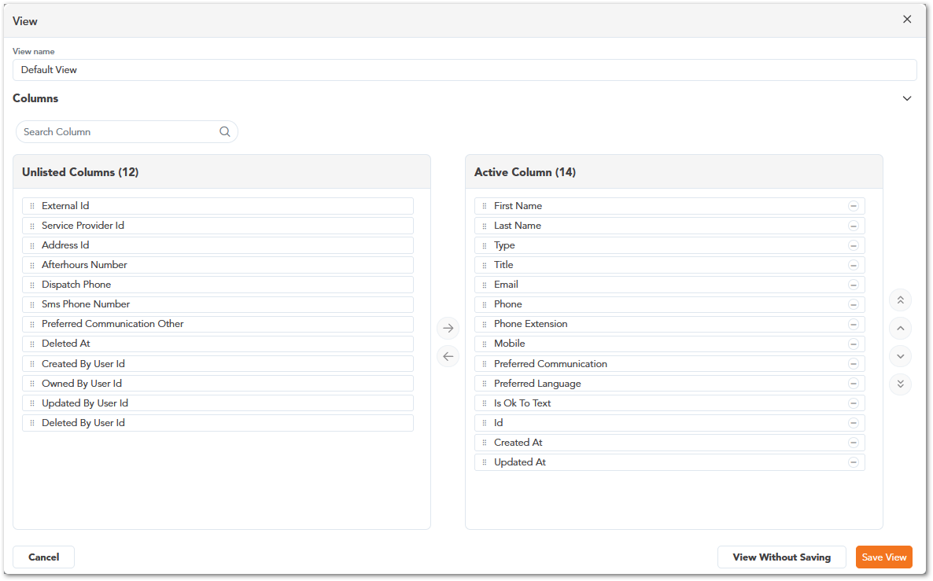

Reports
Users can access shared reports or create custom reports using the Reports dropdown:
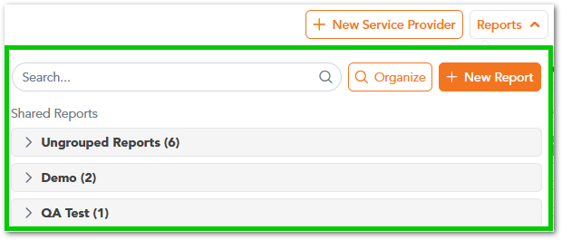
- Click Reports in the upper-right corner of a supported table.
- Select an existing report or click New Report.
- Enter a Report Name and select or create a report group.
- Use Rule and Group to define conditions, including fields, comparison operators, and values.
- Review the matching records and click Preview or Save Report.
The New Report feature allows users to create custom reports by defining specific conditions and filtering criteria. Users can select the fields, comparison operators, and values used to retrieve matching records, preview the results, and save the report for future access.
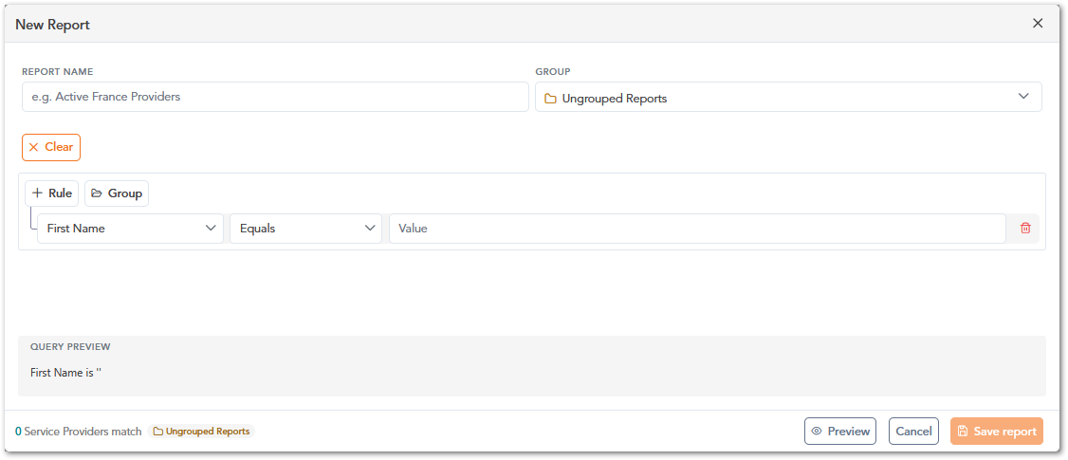

SETTINGS

Header Controls
The Top Navigation Bar is located at the upper-right section of the CUBE interface and provides quick access to commonly used system functions and user-related options. These controls allow users to perform actions such as searching within the system, viewing notifications, accessing system utilities, and managing their user profile.
Icon / Element | Name | Description
 | Search | Allows users to quickly search within the application.
 | Notifications | Displays system alerts, updates, or important notifications.
 | Quick Actions | Provides access to additional system tools or quick actions.
 | Favorites | Allows users to bookmark or access frequently used items.
 | User Profile | Displays the logged-in user information and provides access to account-related options such as profile settings or logout.

Profile
Description of the user profile

Inbox
Description of user inbox

Settings
Description of settings section

USER ROLES
Role assignation for the application users. It could be presented in a table as follows:
Section | Module | AM | CSS | CWS | SPM | Cube Leads | Cube Admin | PSP Specialist | SPM Specialist | Service Provider Team Lead | Tonnage
Dashboardz | PSP Specialist |  |  |  |  |  |  | 
Dashboardz | Servide Provider Summary
Dashboardz | SPM Specialist
Dashboardz | Service Provider Summary
Dashboardz | Tonnage
Customerz | Customers
Customerz | Customer Contacts
Customerz | Sites
Customerz | Reviews
Customerz | CC Transactions
Customerz | Credit Limit Requests
Customerz | Accounting Inquiries
Customerz | Billing Preferences
Salez | Products
Salez | Service Tickets
Salez | Line Items
Salez | Invoices
Salez | AP Hub
Salez | Pricing History
Salez | Z Sight Monitors
Salez | Assets
Operationz | Service Providers
Operationz | Service Provider Contacts
Operationz | Fulfillment Tickets
Operationz | SPM Tickets
Operationz | Pricing Zones
Operationz | Pricings
Operationz | Service Provider Quotes
Operationz | SPM Activities
Operationz | Price Increases
Operationz | Out of Stock
Operationz | Zip Codes
Operationz | Service Provider Ratings
Operationz | Service Provider Business Hours
Zeepz | Leads
Zeepz | Employees
Zeepz | Bonus Points
Zeepz | Badges
Administratorz | Products
Administratorz | Product Codes
Administratorz | Ticket Codes
Administratorz | States
Administratorz | (Combined) Notes
Administratorz | Service Provider Link
Administratorz | Tasks
Administratorz | Lead Sources
Administratorz | Lead Parent
Administratorz | Answered Phone Calls
Userz | Users
Userz | Roles
Userz | Permissions
Userz | Groups
Reportz | Static Reports
Reportz | Custom Reports
Reportz | AI Reports
Reportz | Power BI Reports

Note: This section is mandatory for all applications with role-based access.

WORKING PROCEDURES
Workflows (including diagrams if applicable) for different options within the application.

Account Manager Working Procedures

Create and Manage a Customer Record

Purpose
This procedure describes how an Account Manager creates, searches, and manages customer records within the CUBE platform. Customer records store key information required for service delivery, billing, and operational activities.

Roles and Responsibilities
Role | Responsibility
Account Manager | Creates and manages customer records
Cube Admin | Maintains system configuration and user access if required

Preconditions
- The user must be logged into the CUBE platform.
- The user must have an Account Manager or Cube Admin role.
- The user must have access to Customerz → Customers.
- Required customer information must be available (name, contact details, company).

Process Diagram
Warning: Pending Diagram

Procedure Steps
Create a New Customer
- Navigate to Customerz → Customers.
- Click the New Customer button.
- Enter the required customer information (e.g., name, email, phone, company).
- Review the entered information.
- Click Save to create the record.
- Verify the customer appears in the customer list.
Search and Filter Customers
- Use the Search bar to locate specific customer records.
- Use column filters to refine results (e.g., name, email, company).
- Sort columns as needed to organize the data.
Manage Existing Customers
- Locate the customer in the table.
- Use the Actions column to:
- View details
- Edit the record
- Perform additional actions (if available)
- Save any updates made to the customer record.

System Behavior
Action | System Behavior
User opens Customers module | The system retrieves and displays a list of customer records.
User performs search/filter | The system dynamically updates the table based on criteria.
User creates a customer | The system validates input and stores the record in the database.
User updates a record | The system saves changes and refreshes the table view.

Results
- A new customer record is created and stored in the system.
- Customer information is available for linking to sites, services, and billing.
- Updated records are reflected immediately in the customer list.

Exceptions / Error Handling
Please refer to the troubleshooting section in BookStack.

Manage Service Sites

Purpose
This procedure describes how an Account Manager creates, searches, and manages service site records within the CUBE platform. Service sites represent physical locations where services are delivered.

Roles and Responsibilities
Role | Responsibility
Account Manager | Creates and manages service site records associated with customers
Cube Admin | Maintains system configuration and access permissions if necessary

Preconditions
- The user must be logged into the CUBE platform.
- The user must have an Account Manager or Cube Admin role.
- A customer record must already exist.
- The user must have access to Customerz → Sites.
- Required site information must be available (site name, location, associated customer).

Process Diagram
Warning: Pending Diagram

Procedure Steps
Create a New Site
- Navigate to Customerz → Sites.
- Click the New Site button.
- Enter required site information (site name, location, associated customer).
- Review the entered data.
- Click Save to create the site record.
- Verify the site appears in the list.
Search and Filter Sites
- Use the Search bar to locate specific site records.
- Apply filters based on location, customer, or other available fields.
- Sort columns to organize site information.
Manage Existing Sites
- Locate the site in the table.
- Use the Actions column to:
- View details
- Edit site information
- Perform additional actions (if available)
- Save updates to the site record.

System Behavior
Action | System Behavior
User opens Sites module | The system retrieves and displays site records.
User searches or filters | The system updates the table dynamically.
User creates a site | The system validates data and stores the record.
User updates a site | The system saves changes and refreshes the list.

Results
- A new service site is created and linked to a customer.
- Site records are available for service assignment and operations.
- Updates are reflected immediately in the system.

Exceptions / Erro Handling
Please refer to the troubleshooting section in BookStack.

Customer Success Specialist Working Procedures

Admin Working Procedures

APPROVAL SIGNATURES
Digital signature blocks below are formatted for DocuSign / Adobe Sign.
Name | Role | Digital Signature Block | Date (dd/mm/aa)
Anthony Bures | Digital Development Manager |  | 26/10/2026

--- END OF THE DOCUMENT ---

